UNITED STATES
SECURITIES AND EXCHANGE COMMISSION
WASHINGTON, DC 20549

FORM 8-K

CURRENT REPORT
Pursuant to Section 13 or 15(d)
of the Securities Exchange Act of 1934
Date of report (Date of earliest event reported): September 4, 2026

REIN THERAPEUTICS, INC.
(Exact Name of Registrant as Specified in Its Charter)

Delaware |  | 001-38130 |  | 13-4196017
(State or Other Jurisdiction  of Incorporation) |  | (Commission  File Number) |  | (I.R.S. Employer  Identification Number)

12407 N. Mopac Expy., Suite 250, #390
Austin, Texas 78758
(Address of principal executive offices)
(737) 802-1989
(Registrant’s telephone number, including area code)
N/A
(Former name or former address, if changed since last report)

Check the appropriate box below if the Form 8-K filing is intended to simultaneously satisfy the filing obligations of the registrant under any of the following provisions.

☐ | Written communications pursuant to Rule 425 under the Securities Act (17 CFR 230.425)

☐ | Soliciting material pursuant to Rule 14a-12 under the Exchange Act (17 CFR 240.14d-2(b)

☐ | Pre-commencement communications pursuant to Rule 14d-2(b) under the Exchange Act (17 CFR 240.14d-2(b)

☐ | Pre-commencement communications pursuant to Rule 13e-4(c) under the Exchange Act (17 CFR 240.13e-4(c)
Securities registered pursuant to Section 12(b) of the Act:

Title of each class |  | Trading  Symbol(s) |  | Name of each exchange  on which registered
Common stock: Par value $.001 |  | RNTX |  | Nasdaq Capital Market
Indicate by check mark whether the registrant is an emerging growth company as defined in Rule 405 of the Securities Act of 1933 (§230.405 of this chapter) or Rule 12b-2 of the Securities Exchange Act of 1934 (§240.12b-2 of this chapter).
Emerging growth company ☐
If an emerging growth company, indicate by check mark if the registrant has elected not to use the extended transition period for complying with any new or revised financial accounting standards provided pursuant to Section 13(a) of the Exchange Act. ☐

Item 7.01 | Regulation FD Disclosure.
On September 4, 2026, Rein Therapeutics, Inc. (“Company”) published a presentation concerning its LTI-03 product candidate on its website at https://ir.reintx.com/events-presentations. A copy of the presentation is attached as Exhibit 99.1 hereto.
The information in this Item 7.01, including the presentation attached as Exhibit 99.1, are furnished pursuant to Item 7.01 but shall not be deemed “filed” for any purpose, including for the purposes of Section 18 of the Securities Exchange Act of 1934, as amended (the “Exchange Act”), or otherwise subject to the liabilities of that Section, nor shall either be deemed to be incorporated by reference into any filing under the Securities Act of 1933, as amended, or the Exchange Act, whether made before or after the date hereof, regardless of any general incorporation language in such filing.

Item 9.01 | Financial Statements and Exhibits

(d) Exhibits |  | Method Filing
The following exhibit is furnished with this report:

Exhibit 99.1 |  | The Company’s presentation materials |  | Filed Electronically herewith
104 |  | Cover Page Interactive Data File (embedded within the Inline XBRL document).

SIGNATURES
Pursuant to the requirements of the Securities Exchange Act of 1934, the registrant has duly caused this report to be signed on its behalf by the undersigned hereunto duly authorized.

 |  |  |  |  |  | REIN THERAPEUTICS, INC.
Dated: September 4, 2026 |  |  |  |  |  | /s/ Brian Windsor
 |  |  |  |  |  | Brian Windsor, Ph.D.,
 |  |  |  |  |  | President and Chief Executive Officer
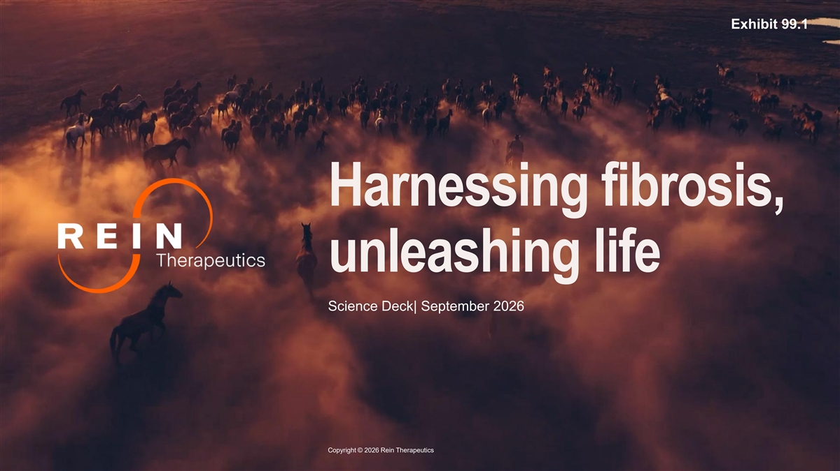
Exhibit 99.1 Harnessing fibrosis, unleashing life Science Deck| September 2026 Copyright © 2026 Rein Therapeutics

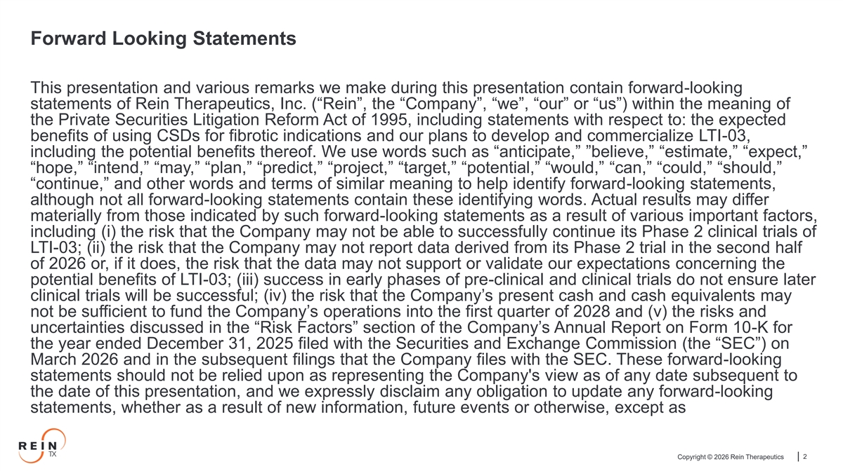
Forward Looking Statements This presentation and various remarks we make during this presentation contain forward-looking statements of Rein Therapeutics, Inc. (“Rein”, the “Company”, “we”, “our” or “us”) within the meaning of the Private Securities Litigation Reform Act of 1995, including statements with respect to: the expected benefits of using CSDs for fibrotic indications and our plans to develop and commercialize LTI-03, including the potential benefits thereof. We use words such as “anticipate,” ”believe,” “estimate,” “expect,” “hope,” “intend,” “may,” “plan,” “predict,” “project,” “target,” “potential,” “would,” “can,” “could,” “should,” “continue,” and other words and terms of similar meaning to help identify forward-looking statements, although not all forward-looking statements contain these identifying words. Actual results may differ materially from those indicated by such forward-looking statements as a result of various important factors, including (i) the risk that the Company may not be able to successfully continue its Phase 2 clinical trials of LTI-03; (ii) the risk that the Company may not report data derived from its Phase 2 trial in the second half of 2026 or, if it does, the risk that the data may not support or validate our expectations concerning the potential benefits of LTI-03; (iii) success in early phases of pre-clinical and clinical trials do not ensure later clinical trials will be successful; (iv) the risk that the Company’s present cash and cash equivalents may not be sufficient to fund the Company’s operations into the first quarter of 2028 and (v) the risks and uncertainties discussed in the “Risk Factors” section of the Company’s Annual Report on Form 10-K for the year ended December 31, 2025 filed with the Securities and Exchange Commission (the “SEC”) on March 2026 and in the subsequent filings that the Company files with the SEC. These forward-looking statements should not be relied upon as representing the Company's view as of any date subsequent to the date of this presentation, and we expressly disclaim any obligation to update any forward-looking statements, whether as a result of new information, future events or otherwise, except as Copyright © 2026 Rein Therapeutics 2

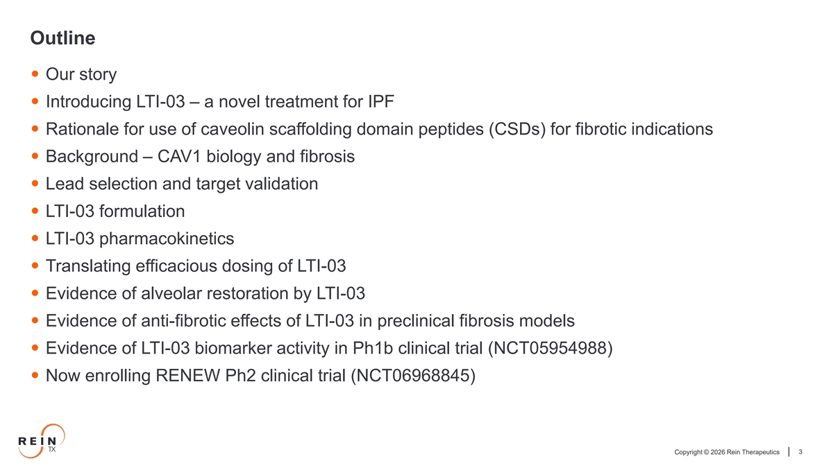
Outline • Our story • Introducing LTI-03 – a novel treatment for IPF • Rationale for use of caveolin scaffolding domain peptides (CSDs) for fibrotic indications • Background – CAV1 biology and fibrosis • Lead selection and target validation • LTI-03 formulation • LTI-03 pharmacokinetics • Translating efficacious dosing of LTI-03 • Evidence of alveolar restoration by LTI-03 • Evidence of anti-fibrotic effects of LTI-03 in preclinical fibrosis models • Evidence of LTI-03 biomarker activity in Ph1b clinical trial (NCT05954988) • Now enrolling RENEW Ph2 clinical trial (NCT06968845) Copyright © 2026 Rein Therapeutics 3


Rein Therapeutics, Inc – Our Story Copyright © 2026 Rein Therapeutics 4

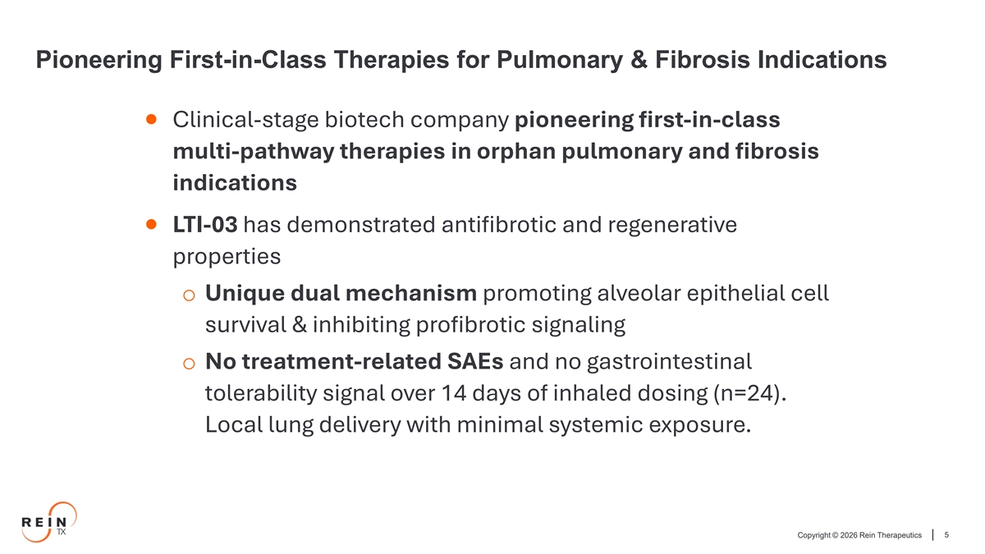
Pioneering First-in-Class Therapies for Pulmonary & Fibrosis Indications • Clinical-stage biotech company pioneering first-in-class multi-pathway therapies in orphan pulmonary and fibrosis indications • LTI-03 has demonstrated antifibrotic and regenerative properties o Unique dual mechanism promoting alveolar epithelial cell survival & inhibiting profibrotic signaling o No treatment-related SAEs and no gastrointestinal tolerability signal over 14 days of inhaled dosing (n=24). Local lung delivery with minimal systemic exposure. Copyright © 2026 Rein Therapeutics 5

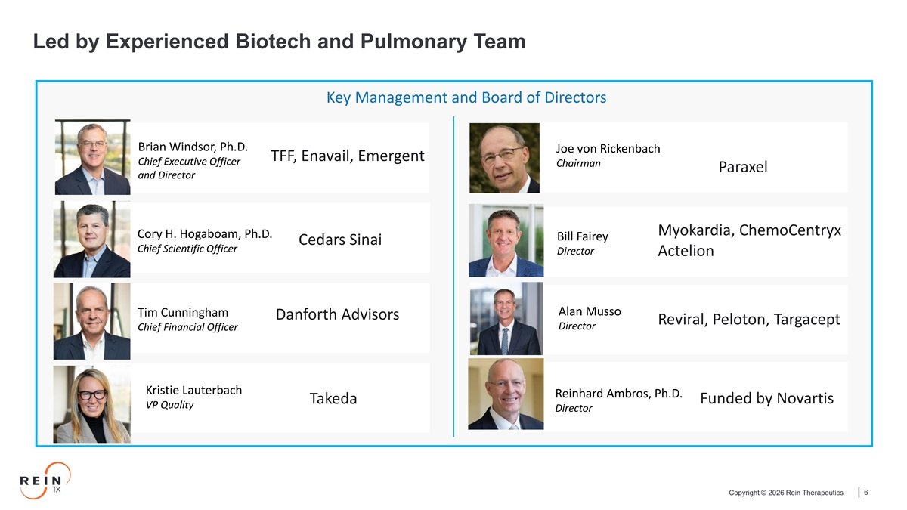
Led by Experienced Biotech and Pulmonary Team Key Management and Board of Directors Brian Windsor, Ph.D. Joe von Rickenbach TFF, Enavail, Emergent Chief Executive Officer Chairman Paraxel and Director Myokardia, ChemoCentryx Cory H. Hogaboam, Ph.D. Bill Fairey Cedars Sinai Chief Scientific Officer Director Actelion Alan Musso Tim Cunningham Danforth Advisors Reviral, Peloton, Targacept Director Chief Financial Officer Kristie Lauterbach Reinhard Ambros, Ph.D. Funded by Novartis Takeda VP Quality Director Copyright © 2026 Rein Therapeutics 6

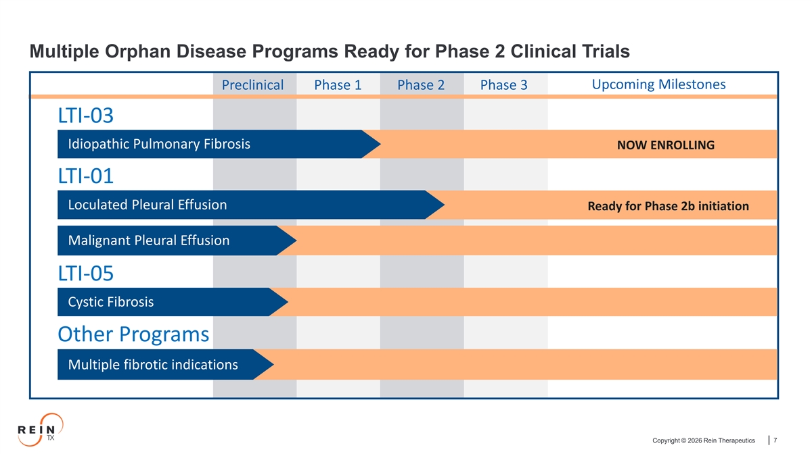
Multiple Orphan Disease Programs Ready for Phase 2 Clinical Trials Upcoming Milestones Preclinical Phase 1 Phase 2 Phase 3 LTI-03 Idiopathic Pulmonary Fibrosis NOW ENROLLING LTI-01 Loculated Pleural Effusion Ready for Phase 2b initiation Malignant Pleural Effusion LTI-05 Cystic Fibrosis Other Programs Multiple fibrotic indications Copyright © 2026 Rein Therapeutics 7

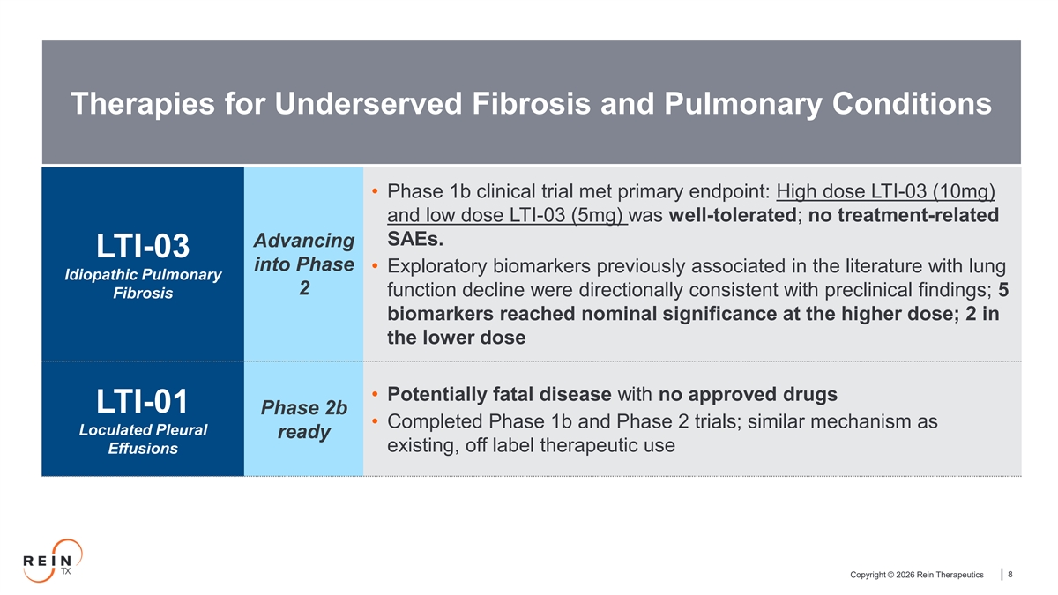
Therapies for Underserved Fibrosis and Pulmonary Conditions • Phase 1b clinical trial met primary endpoint: High dose LTI-03 (10mg) and low dose LTI-03 (5mg) was well-tolerated; no treatment-related SAEs. Advancing LTI-03 into Phase • Exploratory biomarkers previously associated in the literature with lung Idiopathic Pulmonary 2 function decline were directionally consistent with preclinical findings; 5 Fibrosis biomarkers reached nominal significance at the higher dose; 2 in the lower dose • Potentially fatal disease with no approved drugs LTI-01 Phase 2b • Completed Phase 1b and Phase 2 trials; similar mechanism as Loculated Pleural ready existing, off label therapeutic use Effusions Copyright © 2026 Rein Therapeutics 8

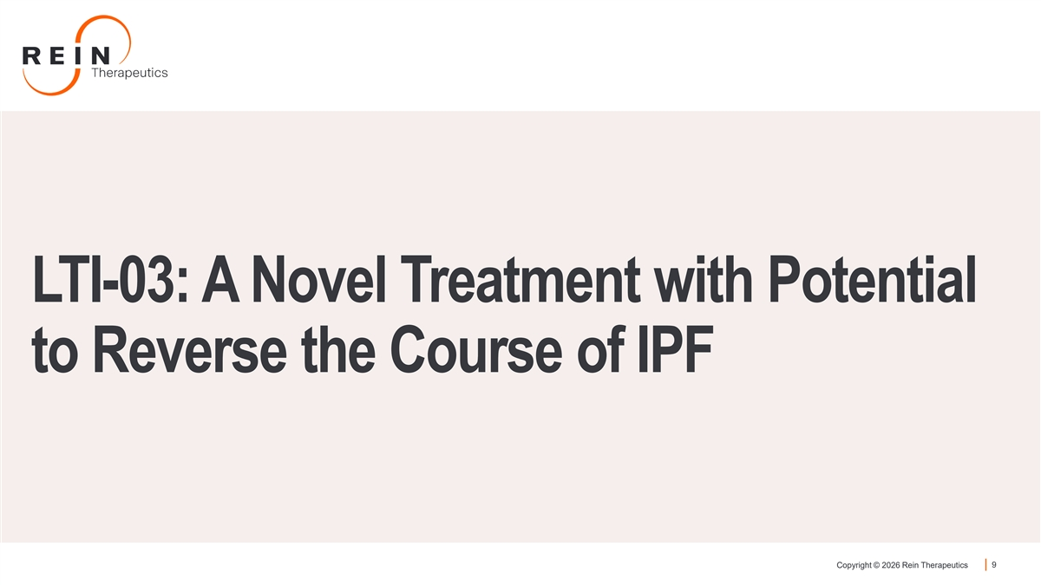
LTI-03: A Novel Treatment with Potential to Reverse the Course of IPF Copyright © 2026 Rein Therapeutics 9

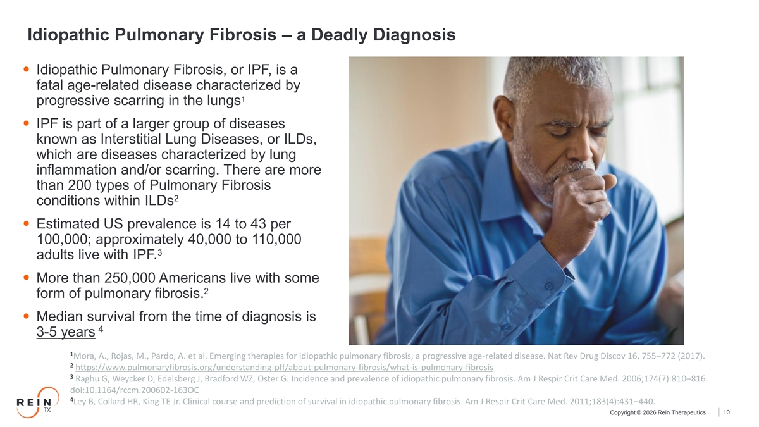
Idiopathic Pulmonary Fibrosis – a Deadly Diagnosis • Idiopathic Pulmonary Fibrosis, or IPF, is a fatal age-related disease characterized by 1 progressive scarring in the lungs • IPF is part of a larger group of diseases known as Interstitial Lung Diseases, or ILDs, which are diseases characterized by lung inflammation and/or scarring. There are more than 200 types of Pulmonary Fibrosis 2 conditions within ILDs • Estimated US prevalence is 14 to 43 per 100,000; approximately 40,000 to 110,000 3 adults live with IPF. • More than 250,000 Americans live with some 2 form of pulmonary fibrosis. • Median survival from the time of diagnosis is 4 3-5 years 1 Mora, A., Rojas, M., Pardo, A. et al. Emerging therapies for idiopathic pulmonary fibrosis, a progressive age-related disease. Nat Rev Drug Discov 16, 755–772 (2017). 2 https://www.pulmonaryfibrosis.org/understanding-pff/about-pulmonary-fibrosis/what-is-pulmonary-fibrosis 3 Raghu G, Weycker D, Edelsberg J, Bradford WZ, Oster G. Incidence and prevalence of idiopathic pulmonary fibrosis. Am J Respir Crit Care Med. 2006;174(7):810–816. doi:10.1164/rccm.200602-163OC 4 Ley B, Collard HR, King TE Jr. Clinical course and prediction of survival in idiopathic pulmonary fibrosis. Am J Respir Crit Care Med. 2011;183(4):431–440. Copyright © 2026 Rein Therapeutics 10

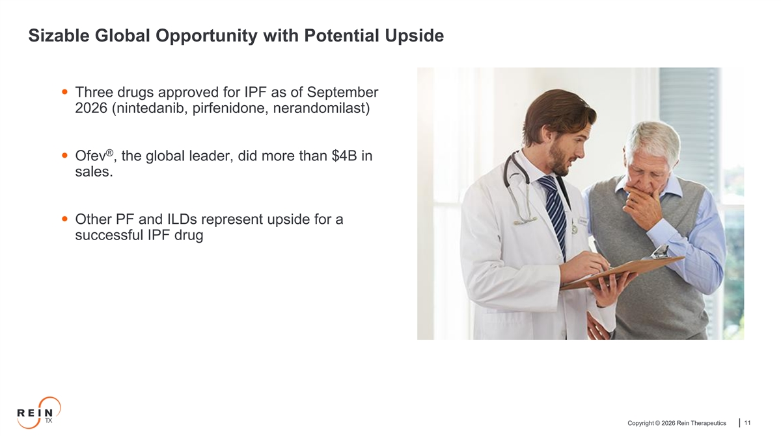
Sizable Global Opportunity with Potential Upside • Three drugs approved for IPF as of September 2026 (nintedanib, pirfenidone, nerandomilast) ®️ • Ofev , the global leader, did more than $4B in sales. • Other PF and ILDs represent upside for a successful IPF drug Copyright © 2026 Rein Therapeutics 11

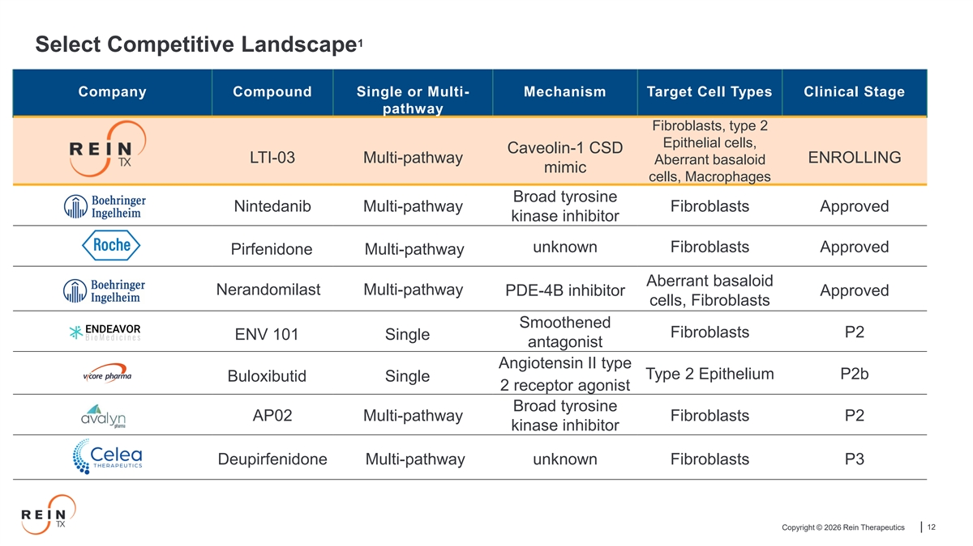
1 Select Competitive Landscape Company Compound Single or Multi- Mechanism Target Cell Types Clinical Stage pathway Fibroblasts, type 2 Epithelial cells, Caveolin-1 CSD LTI-03 Multi-pathway ENROLLING Aberrant basaloid mimic cells, Macrophages Broad tyrosine Nintedanib Multi-pathway Fibroblasts Approved kinase inhibitor unknown Fibroblasts Approved Pirfenidone Multi-pathway Aberrant basaloid Nerandomilast Multi-pathway PDE-4B inhibitor Approved cells, Fibroblasts Smoothened Fibroblasts P2 ENV 101 Single antagonist Angiotensin II type Type 2 Epithelium P2b Buloxibutid Single 2 receptor agonist Broad tyrosine AP02 Multi-pathway Fibroblasts P2 kinase inhibitor Deupirfenidone Multi-pathway unknown Fibroblasts P3 Copyright © 2026 Rein Therapeutics 12

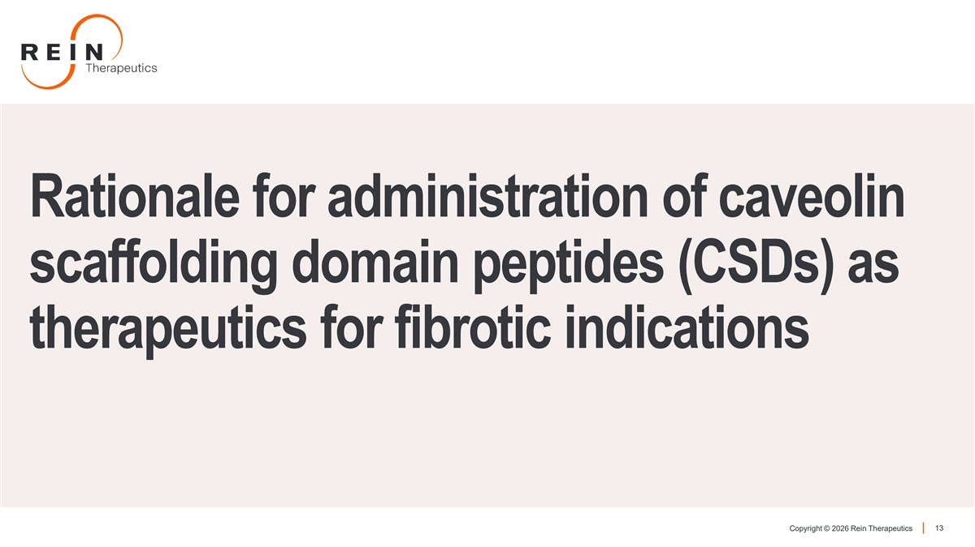
Rationale for administration of caveolin scaffolding domain peptides (CSDs) as therapeutics for fibrotic indications Copyright © 2026 Rein Therapeutics 13

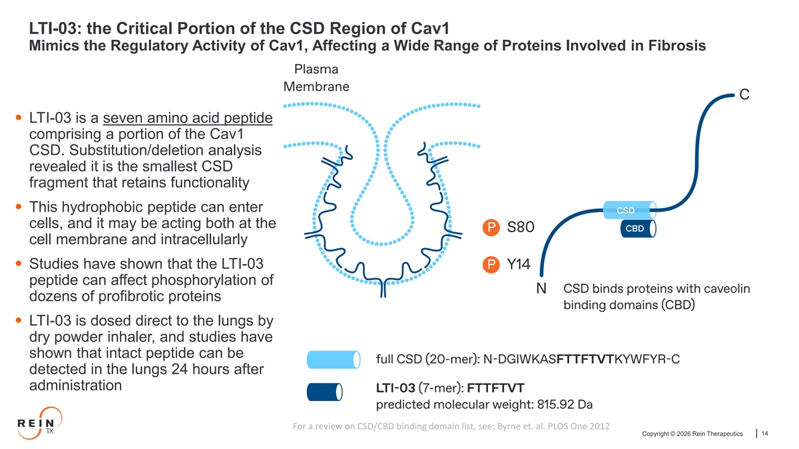
LTI-03: the Critical Portion of the CSD Region of Cav1 Mimics the Regulatory Activity of Cav1, Affecting a Wide Range of Proteins Involved in Fibrosis • LTI-03 is a seven amino acid peptide comprising a portion of the Cav1 CSD. Substitution/deletion analysis revealed it is the smallest CSD fragment that retains functionality • This hydrophobic peptide can enter cells, and it may be acting both at the cell membrane and intracellularly • Studies have shown that the LTI-03 peptide can affect phosphorylation of dozens of profibrotic proteins • LTI-03 is dosed direct to the lungs by dry powder inhaler, and studies have shown that intact peptide can be detected in the lungs 24 hours after administration For a review on CSD/CBD binding domain list, see: Byrne et. al. PLOS One 2012 Copyright © 2026 Rein Therapeutics 14

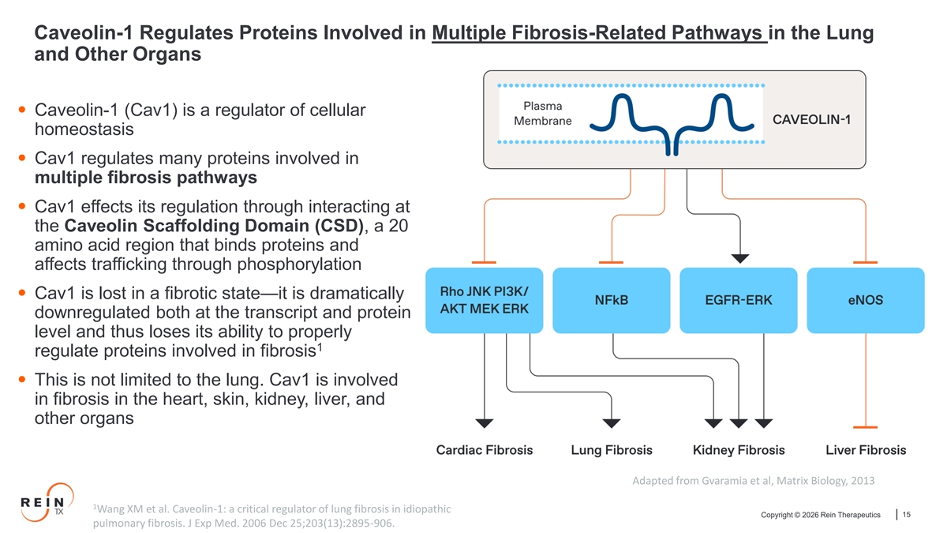
Caveolin-1 Regulates Proteins Involved in Multiple Fibrosis-Related Pathways in the Lung and Other Organs • Caveolin-1 (Cav1) is a regulator of cellular homeostasis • Cav1 regulates many proteins involved in multiple fibrosis pathways • Cav1 effects its regulation through interacting at the Caveolin Scaffolding Domain (CSD), a 20 amino acid region that binds proteins and affects trafficking through phosphorylation • Cav1 is lost in a fibrotic state—it is dramatically downregulated both at the transcript and protein level and thus loses its ability to properly 1 regulate proteins involved in fibrosis • This is not limited to the lung. Cav1 is involved in fibrosis in the heart, skin, kidney, liver, and other organs Adapted from Gvaramia et al, Matrix Biology, 2013 1 Wang XM et al. Caveolin-1: a critical regulator of lung fibrosis in idiopathic Copyright © 2026 Rein Therapeutics 15 pulmonary fibrosis. J Exp Med. 2006 Dec 25;203(13):2895-906.

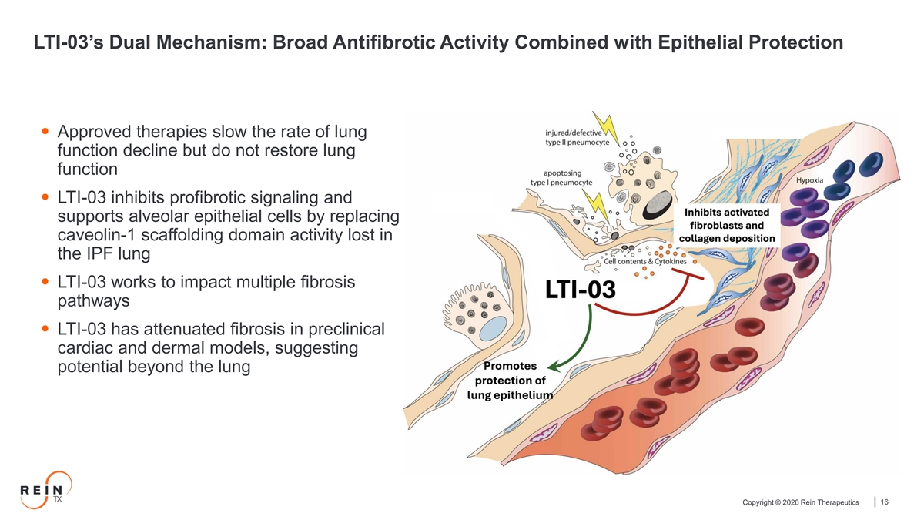
LTI-03’s Dual Mechanism: Broad Antifibrotic Activity Combined with Epithelial Protection • Approved therapies slow the rate of lung function decline but do not restore lung function • LTI-03 inhibits profibrotic signaling and supports alveolar epithelial cells by replacing caveolin-1 scaffolding domain activity lost in the IPF lung • LTI-03 works to impact multiple fibrosis pathways • LTI-03 has attenuated fibrosis in preclinical cardiac and dermal models, suggesting potential beyond the lung Copyright © 2026 Rein Therapeutics 16

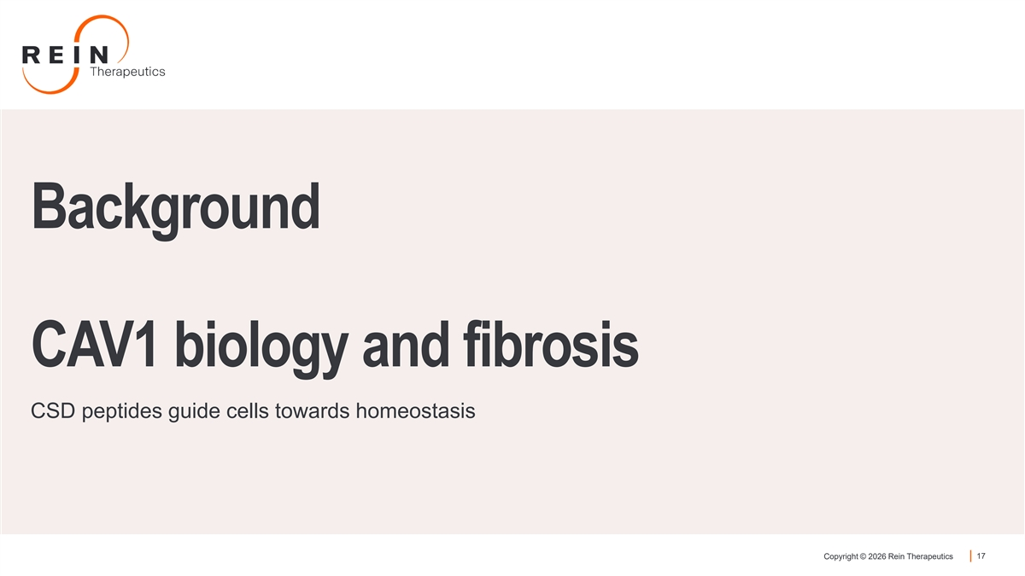
Background CAV1 biology and fibrosis CSD peptides guide cells towards homeostasis Copyright © 2026 Rein Therapeutics 17

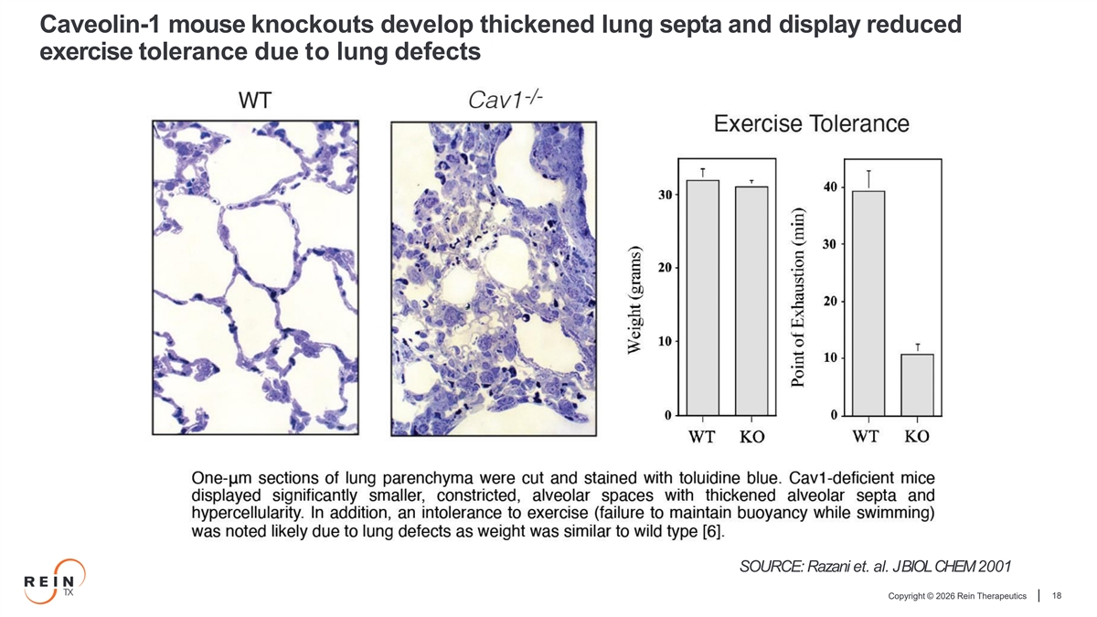
Caveolin-1 mouse knockouts develop thickened lung septa and display reduced exercise tolerance due to lung defects SOURCE: Razani et. al. JBIOLCHEM2001 Copyright © 2026 Rein Therapeutics 18

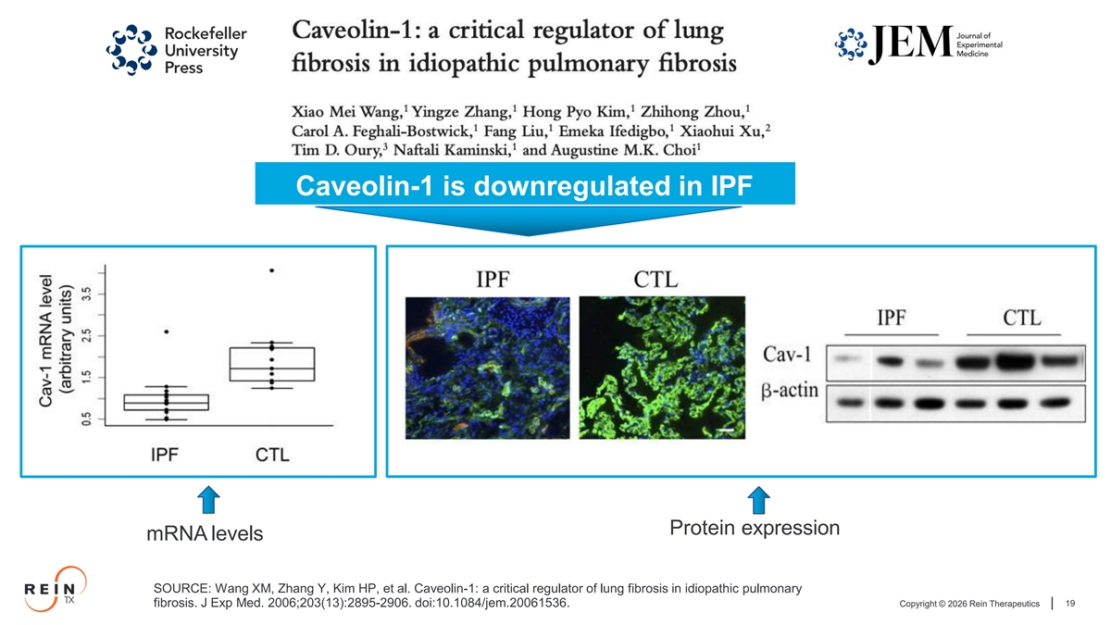
Caveolin-1 is downregulated in IPF Protein expression mRNA levels SOURCE: Wang XM, Zhang Y, Kim HP, et al. Caveolin-1: a critical regulator of lung fibrosis in idiopathic pulmonary Copyright © 2026 Rein Therapeutics 19 fibrosis. J Exp Med. 2006;203(13):2895-2906. doi:10.1084/jem.20061536.

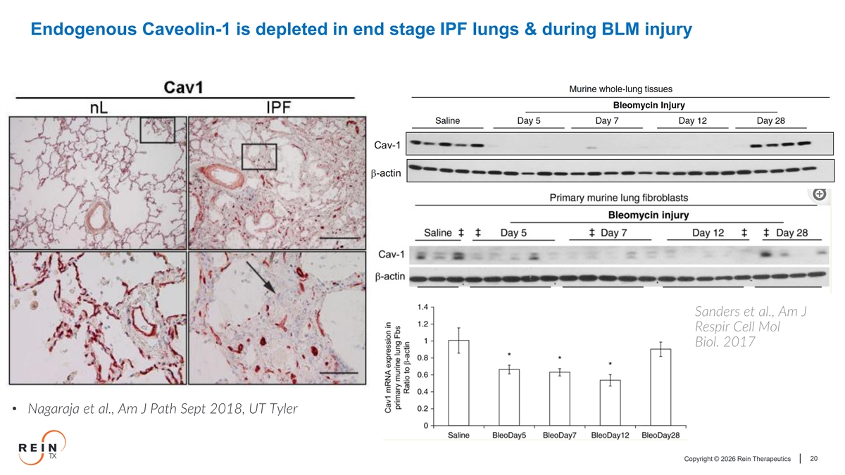
Endogenous Caveolin-1 is depleted in end stage IPF lungs & during BLM injury Sanders et al., Am J Respir Cell Mol Biol. 2017 • Nagaraja et al., Am J Path Sept 2018, UT Tyler Copyright © 2026 Rein Therapeutics 20

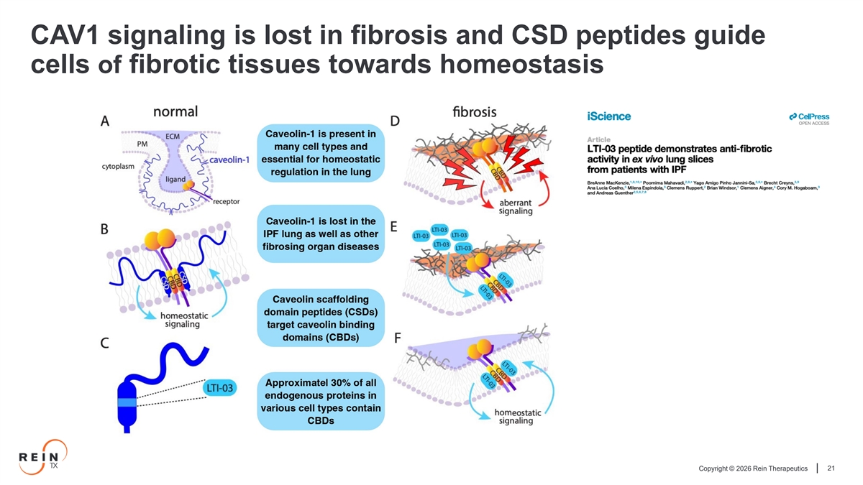
CAV1 signaling is lost in fibrosis and CSD peptides guide cells of fibrotic tissues towards homeostasis Copyright © 2026 Rein Therapeutics 21

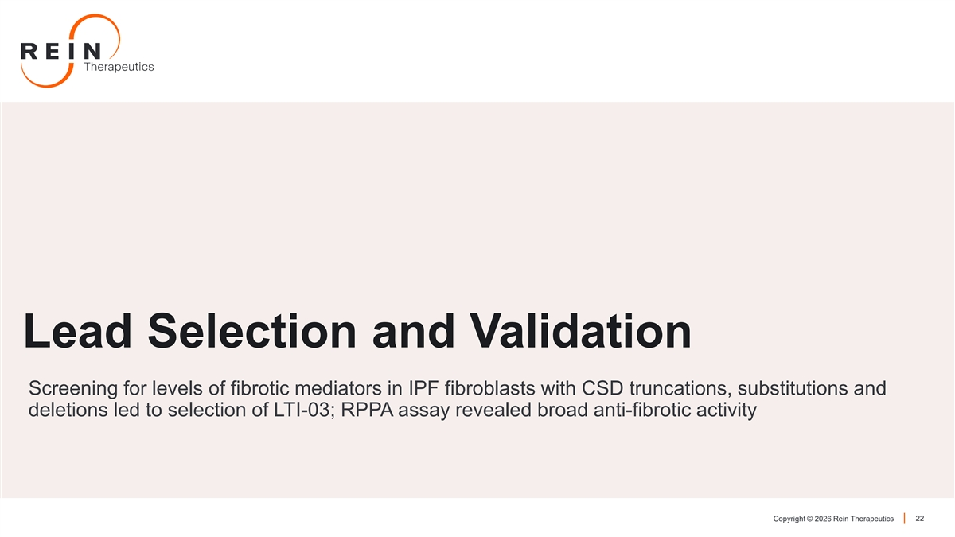
Lead Selection and Validation Screening for levels of fibrotic mediators in IPF fibroblasts with CSD truncations, substitutions and deletions led to selection of LTI-03; RPPA assay revealed broad anti-fibrotic activity Copyright © 2026 Rein Therapeutics 22

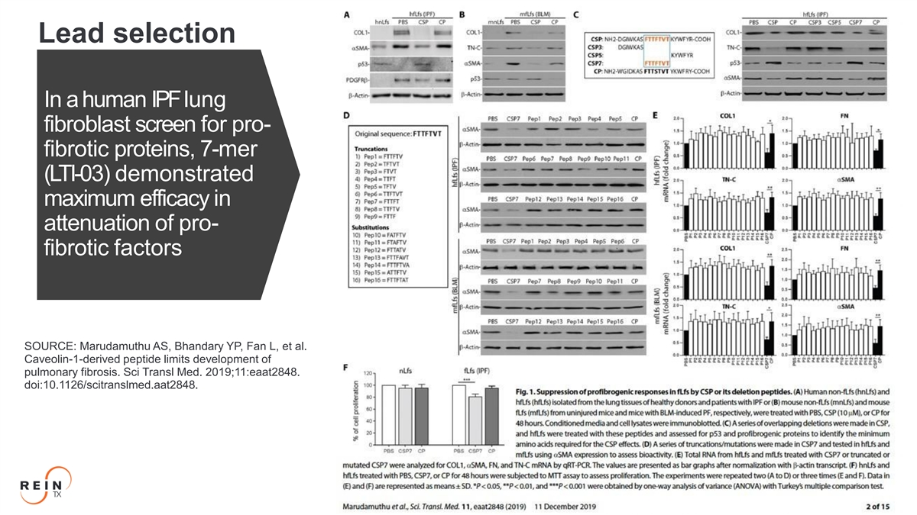
Lead selection In ahuman IPFlung fibroblast screen for pro- fibrotic proteins, 7-mer (LTI-03) demonstrated maximum efficacy in attenuation of pro- fibrotic factors SOURCE: Marudamuthu AS, Bhandary YP, Fan L, et al. Caveolin-1-derived peptide limits development of pulmonary fibrosis. Sci Transl Med. 2019;11:eaat2848. doi:10.1126/scitranslmed.aat2848. Copyright © 2026 Rein Therapeutics 23

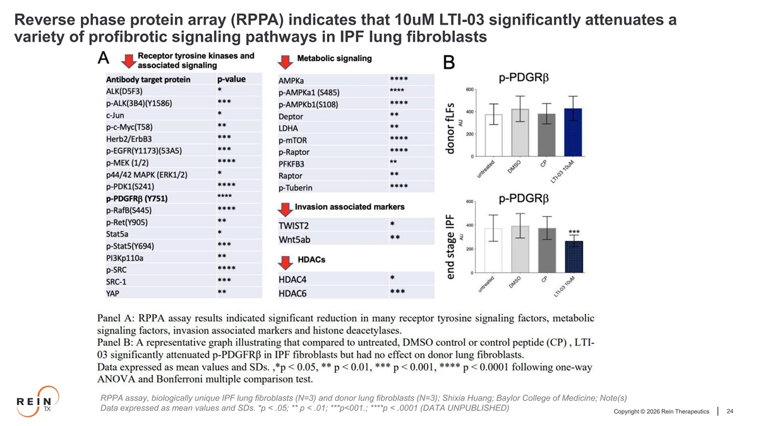
Reverse phase protein array (RPPA) indicates that 10uM LTI-03 significantly attenuates a variety of profibrotic signaling pathways in IPF lung fibroblasts RPPA assay, biologically unique IPF lung fibroblasts (N=3) and donor lung fibroblasts (N=3); Shixia Huang; Baylor College of Medicine; Note(s) Data expressed as mean values and SDs. *p < .05; ** p < .01; ***p<001.; ****p < .0001 (DATA UNPUBLISHED) Copyright © 2026 Rein Therapeutics 24

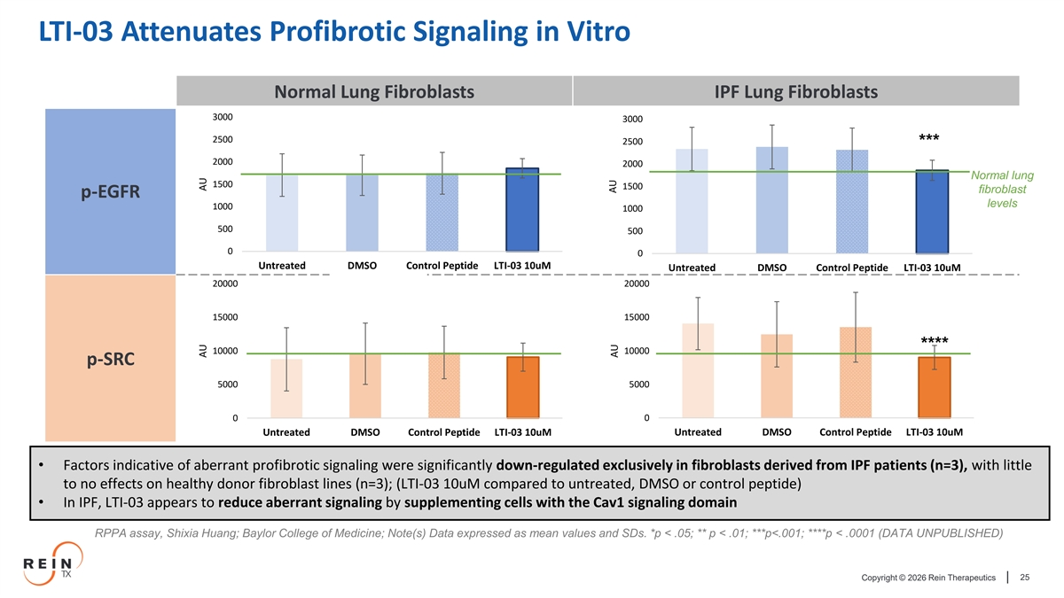
LTI-03 Attenuates Profibrotic Signaling in Vitro Normal Lung Fibroblasts IPF Lung Fibroblasts 3000 3000 2500 2500 *** 2000 2000 Normal lung 1500 1500 fibroblast p-EGFR levels 1000 1000 500 500 0 0 Untreated DMSO Control Peptide LTI-03 10uM Untreated DMSO Control Peptide LTI-03 10uM 20000 20000 15000 15000 **** 10000 10000 p-SRC 5000 5000 0 0 Untreated DMSO Control Peptide LTI-03 10uM Untreated DMSO Control Peptide LTI-03 10uM • Factors indicative of aberrant profibrotic signaling were significantly down-regulated exclusively in fibroblasts derived from IPF patients (n=3), with little to no effects on healthy donor fibroblast lines (n=3); (LTI-03 10uM compared to untreated, DMSO or control peptide) • In IPF, LTI-03 appears to reduce aberrant signaling by supplementing cells with the Cav1 signaling domain RPPA assay, Shixia Huang; Baylor College of Medicine; Note(s) Data expressed as mean values and SDs. *p < .05; ** p < .01; ***p<.001; ****p < .0001 (DATA UNPUBLISHED) Copyright © 2026 Rein Therapeutics 25 AU AU AU AU

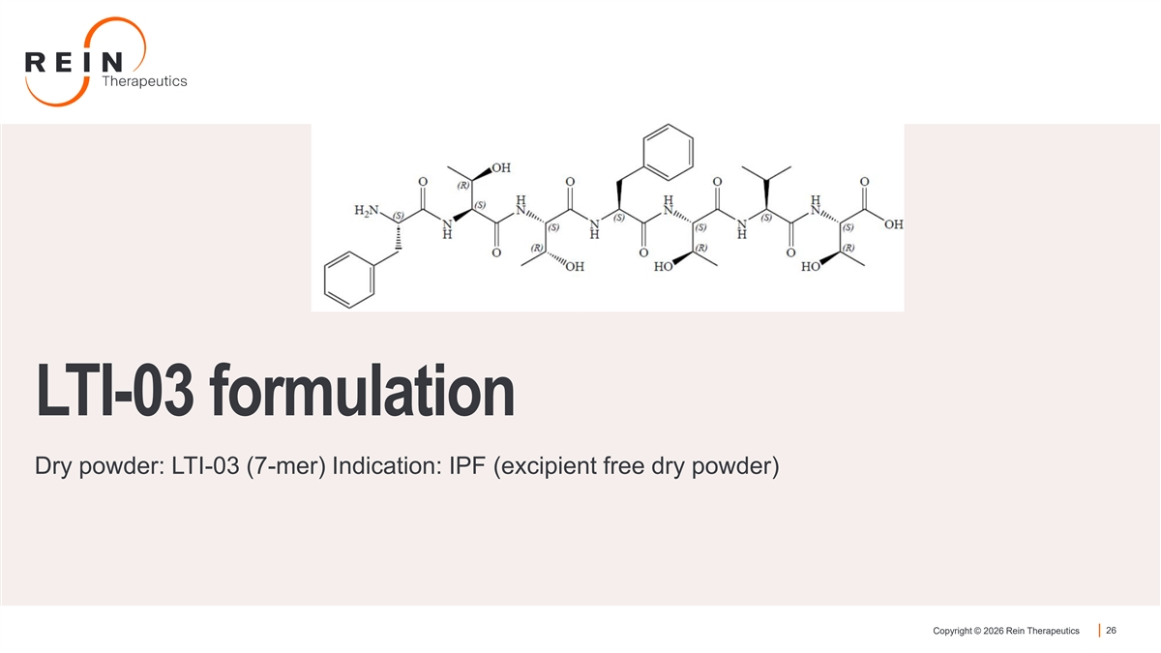
LTI-03 formulation Dry powder: LTI-03 (7-mer) Indication: IPF (excipient free dry powder) Copyright © 2026 Rein Therapeutics 26

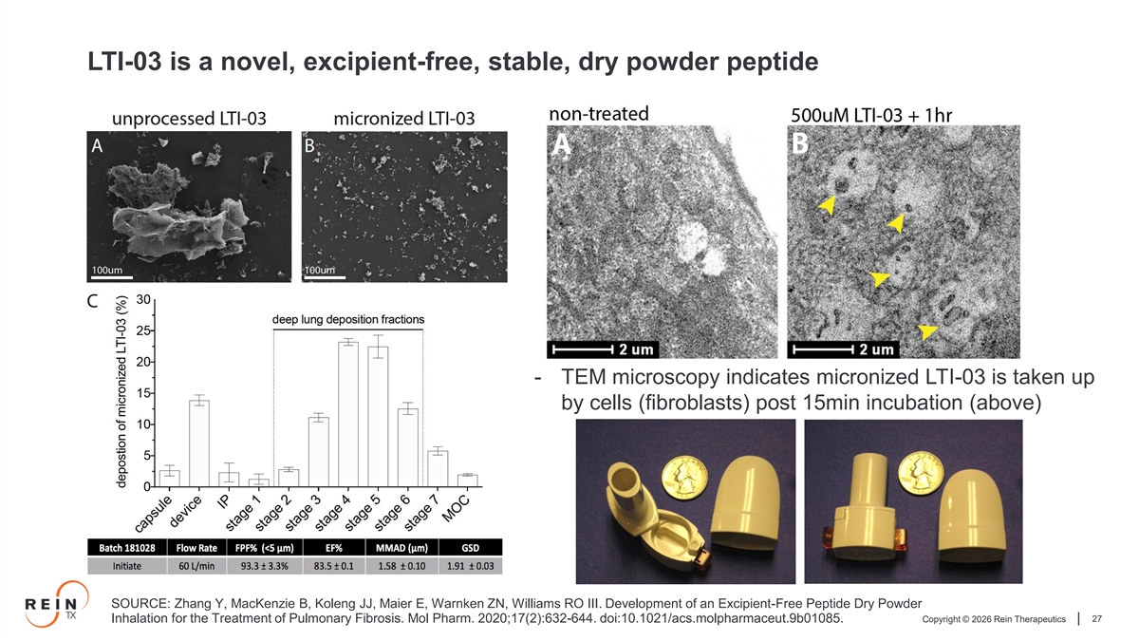
LTI-03 is a novel, excipient-free, stable, dry powder peptide - TEM microscopy indicates micronized LTI-03 is taken up by cells (fibroblasts) post 15min incubation (above) SOURCE: Zhang Y, MacKenzie B, Koleng JJ, Maier E, Warnken ZN, Williams RO III. Development of an Excipient-Free Peptide Dry Powder Copyright © 2026 Rein Therapeutics 27 Inhalation for the Treatment of Pulmonary Fibrosis. Mol Pharm. 2020;17(2):632-644. doi:10.1021/acs.molpharmaceut.9b01085.

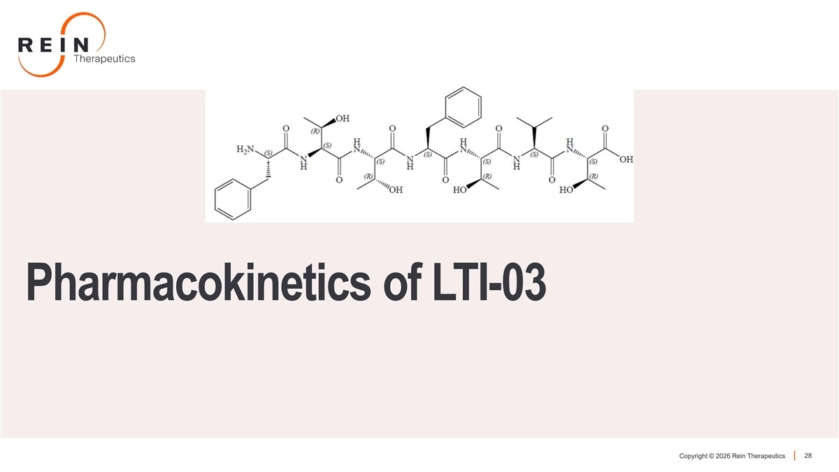
Pharmacokinetics of LTI-03 Copyright © 2026 Rein Therapeutics 28

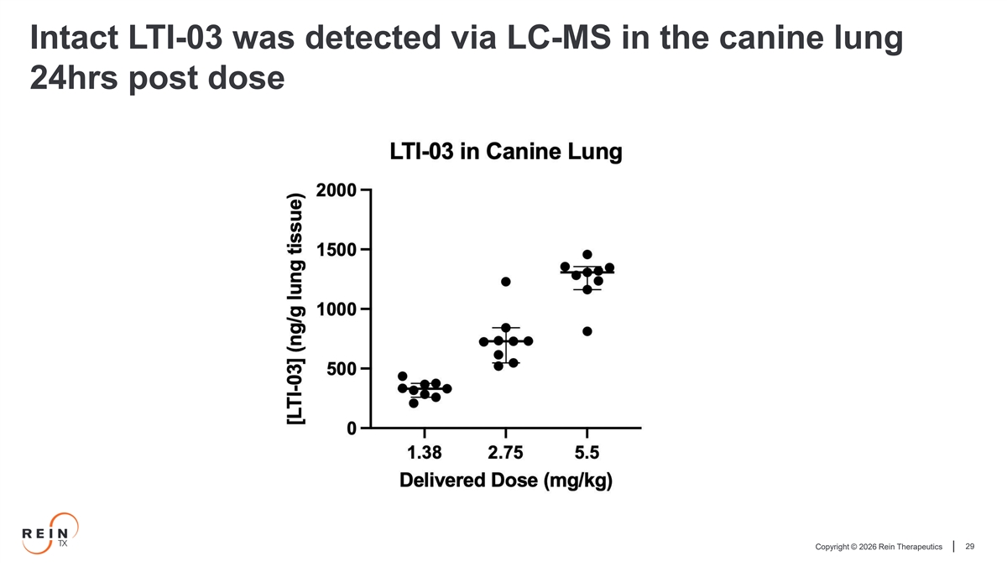
Intact LTI-03 was detected via LC-MS in the canine lung 24hrs post dose Copyright © 2026 Rein Therapeutics 29

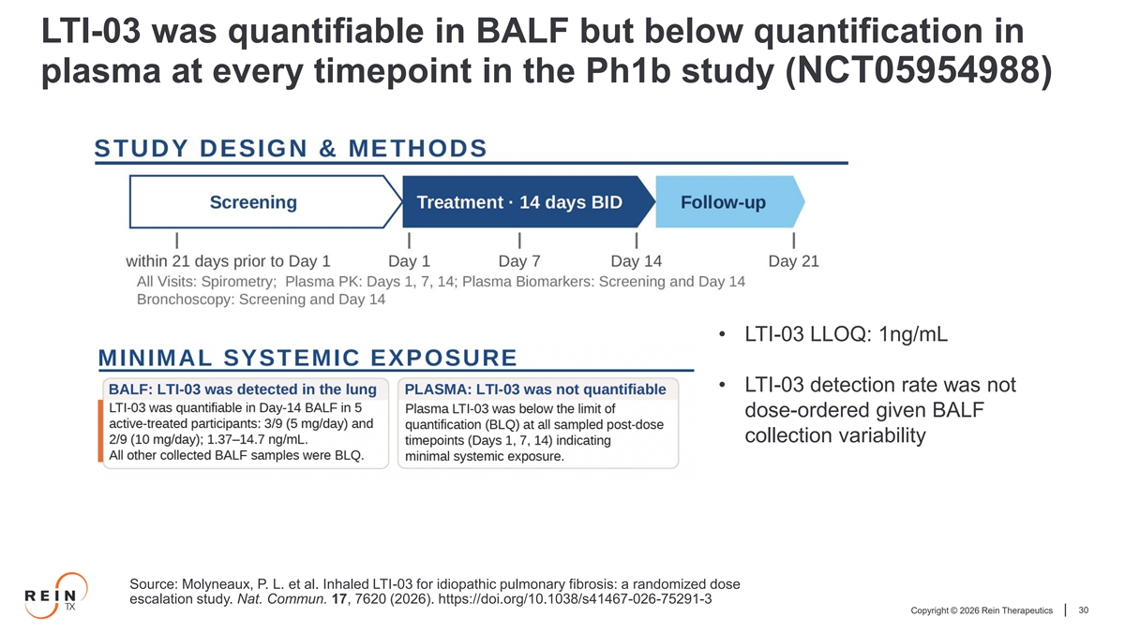
LTI-03 was quantifiable in BALF but below quantification in plasma at every timepoint in the Ph1b study (NCT05954988) • LTI-03 LLOQ: 1ng/mL • LTI-03 detection rate was not dose-ordered given BALF collection variability Source: Molyneaux, P. L. et al. Inhaled LTI-03 for idiopathic pulmonary fibrosis: a randomized dose escalation study. Nat. Commun. 17, 7620 (2026). https://doi.org/10.1038/s41467-026-75291-3 Copyright © 2026 Rein Therapeutics 30

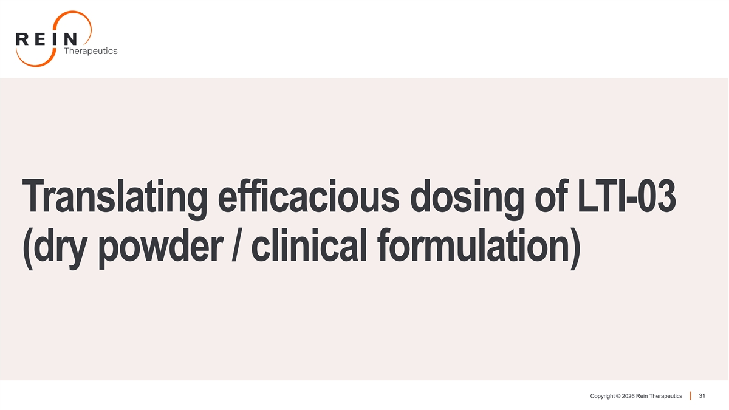
Translating efficacious dosing of LTI-03 (dry powder / clinical formulation) Copyright © 2026 Rein Therapeutics 31

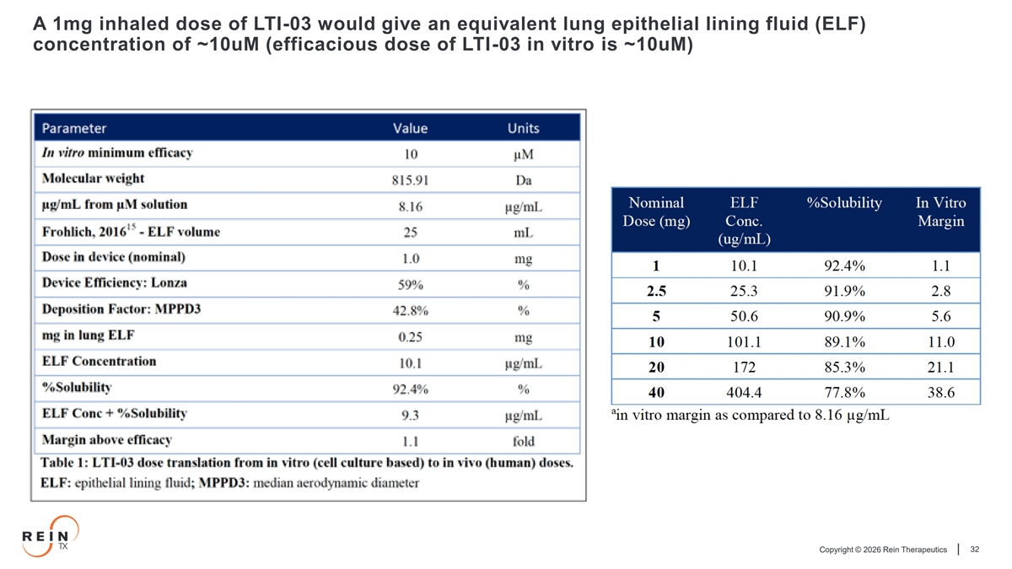
A 1mg inhaled dose of LTI-03 would give an equivalent lung epithelial lining fluid (ELF) concentration of ~10uM (efficacious dose of LTI-03 in vitro is ~10uM) Copyright © 2026 Rein Therapeutics 32

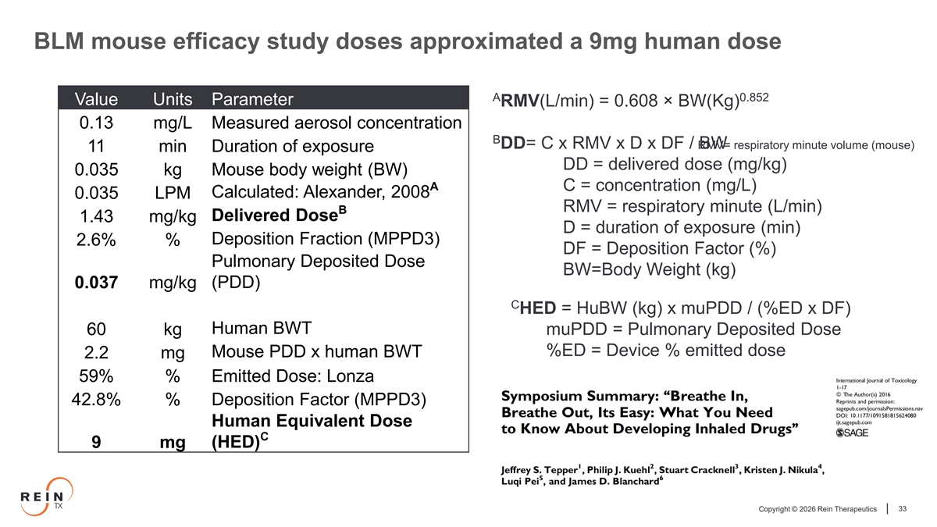
BLM mouse efficacy study doses approximated a 9mg human dose A 0.852 Value Units Parameter RMV(L/min) = 0.608 × BW(Kg) 0.13 mg/L Measured aerosol concentration B DD= C x RMV x D x DF / RM BW V= respiratory minute volume (mouse) 11 min Duration of exposure DD = delivered dose (mg/kg) 0.035 kg Mouse body weight (BW) A C = concentration (mg/L) Calculated: Alexander, 2008 0.035 LPM RMV = respiratory minute (L/min) B Delivered Dose 1.43 mg/kg D = duration of exposure (min) Deposition Fraction (MPPD3) 2.6% % DF = Deposition Factor (%) Pulmonary Deposited Dose BW=Body Weight (kg) (PDD) 0.037 mg/kg C HED = HuBW (kg) x muPDD / (%ED x DF) Human BWT muPDD = Pulmonary Deposited Dose 60 kg %ED = Device % emitted dose Mouse PDD x human BWT 2.2 mg 59% % Emitted Dose: Lonza 42.8% % Deposition Factor (MPPD3) Human Equivalent Dose C 9 mg (HED) Copyright © 2026 Rein Therapeutics 33

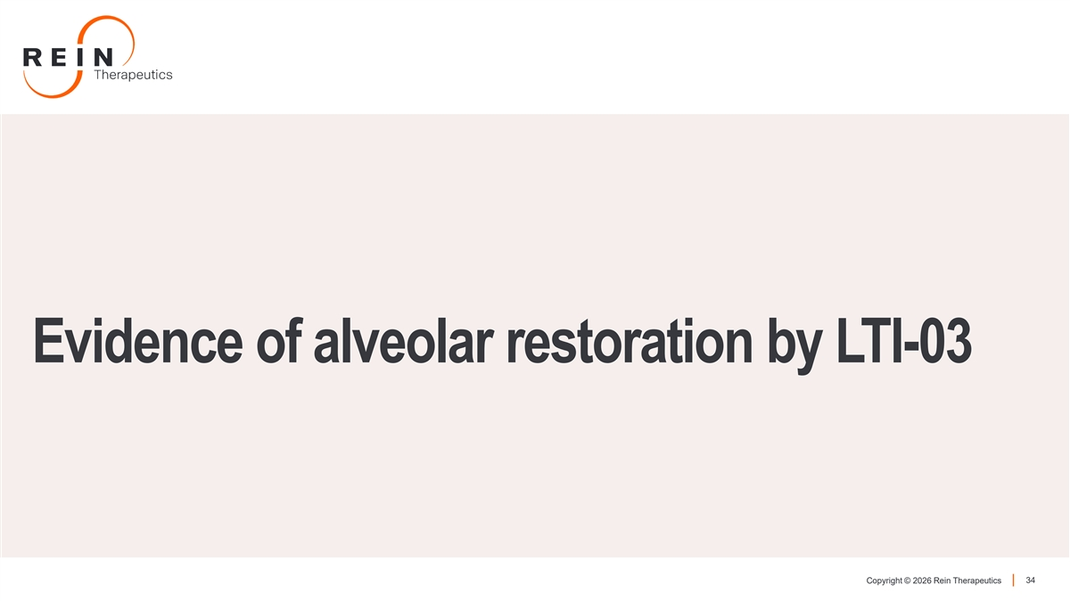
Evidence of alveolar restoration by LTI-03 Copyright © 2026 Rein Therapeutics 34

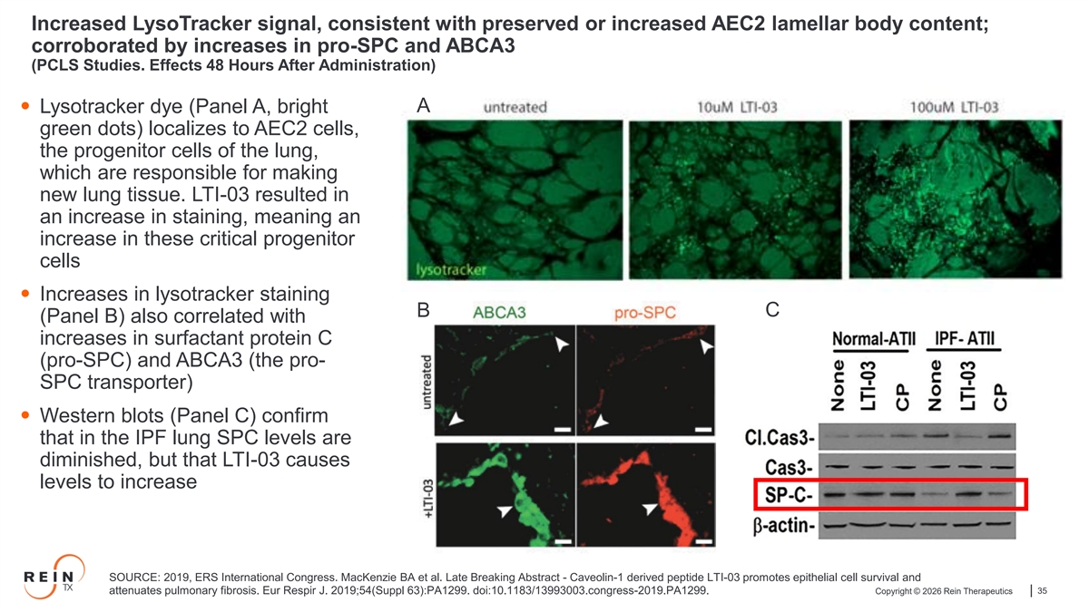
Increased LysoTracker signal, consistent with preserved or increased AEC2 lamellar body content; corroborated by increases in pro-SPC and ABCA3 (PCLS Studies. Effects 48 Hours After Administration) A • Lysotracker dye (Panel A, bright green dots) localizes to AEC2 cells, the progenitor cells of the lung, which are responsible for making new lung tissue. LTI-03 resulted in an increase in staining, meaning an increase in these critical progenitor cells • Increases in lysotracker staining C B (Panel B) also correlated with increases in surfactant protein C (pro-SPC) and ABCA3 (the pro- SPC transporter) • Western blots (Panel C) confirm that in the IPF lung SPC levels are diminished, but that LTI-03 causes levels to increase SOURCE: 2019, ERS International Congress. MacKenzie BA et al. Late Breaking Abstract - Caveolin-1 derived peptide LTI-03 promotes epithelial cell survival and attenuates pulmonary fibrosis. Eur Respir J. 2019;54(Suppl 63):PA1299. doi:10.1183/13993003.congress-2019.PA1299. Copyright © 2026 Rein Therapeutics 35

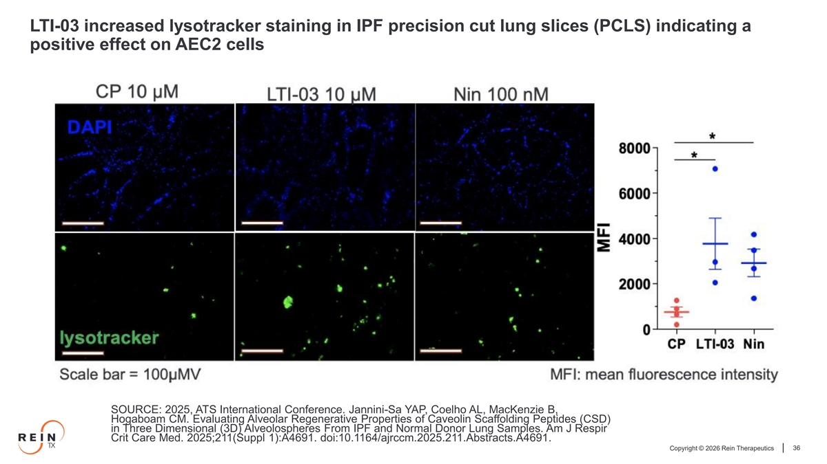
LTI-03 increased lysotracker staining in IPF precision cut lung slices (PCLS) indicating a positive effect on AEC2 cells SOURCE: 2025, ATS International Conference. Jannini-Sa YAP, Coelho AL, MacKenzie B, Hogaboam CM. Evaluating Alveolar Regenerative Properties of Caveolin Scaffolding Peptides (CSD) in Three Dimensional (3D) Alveolospheres From IPF and Normal Donor Lung Samples. Am J Respir Crit Care Med. 2025;211(Suppl 1):A4691. doi:10.1164/ajrccm.2025.211.Abstracts.A4691. Copyright © 2026 Rein Therapeutics 36

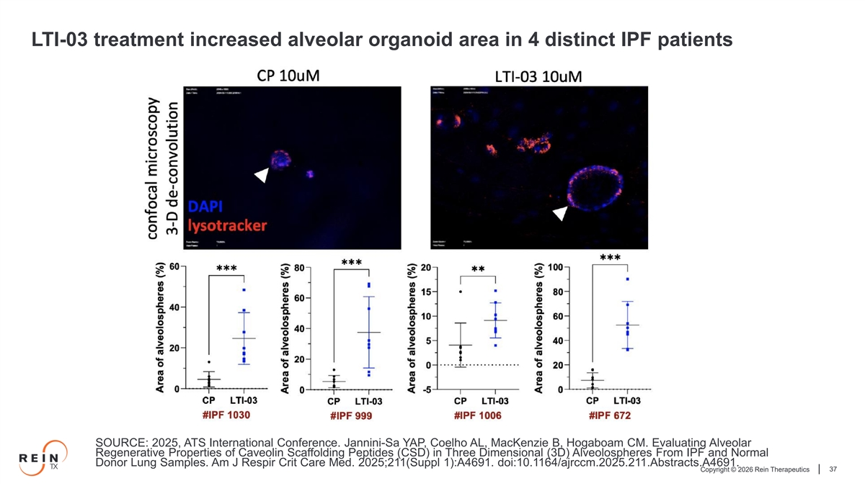
LTI-03 treatment increased alveolar organoid area in 4 distinct IPF patients SOURCE: 2025, ATS International Conference. Jannini-Sa YAP, Coelho AL, MacKenzie B, Hogaboam CM. Evaluating Alveolar Regenerative Properties of Caveolin Scaffolding Peptides (CSD) in Three Dimensional (3D) Alveolospheres From IPF and Normal Donor Lung Samples. Am J Respir Crit Care Med. 2025;211(Suppl 1):A4691. doi:10.1164/ajrccm.2025.211.Abstracts.A4691. Copyright © 2026 Rein Therapeutics 37

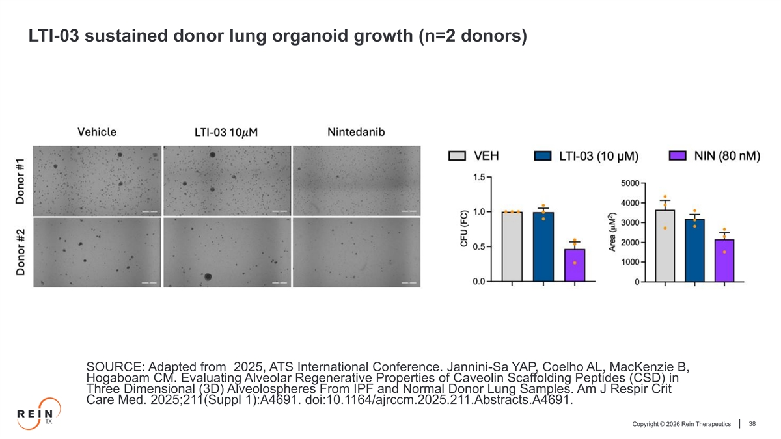
LTI-03 sustained donor lung organoid growth (n=2 donors) SOURCE: Adapted from 2025, ATS International Conference. Jannini-Sa YAP, Coelho AL, MacKenzie B, Hogaboam CM. Evaluating Alveolar Regenerative Properties of Caveolin Scaffolding Peptides (CSD) in Three Dimensional (3D) Alveolospheres From IPF and Normal Donor Lung Samples. Am J Respir Crit Care Med. 2025;211(Suppl 1):A4691. doi:10.1164/ajrccm.2025.211.Abstracts.A4691. Copyright © 2026 Rein Therapeutics 38

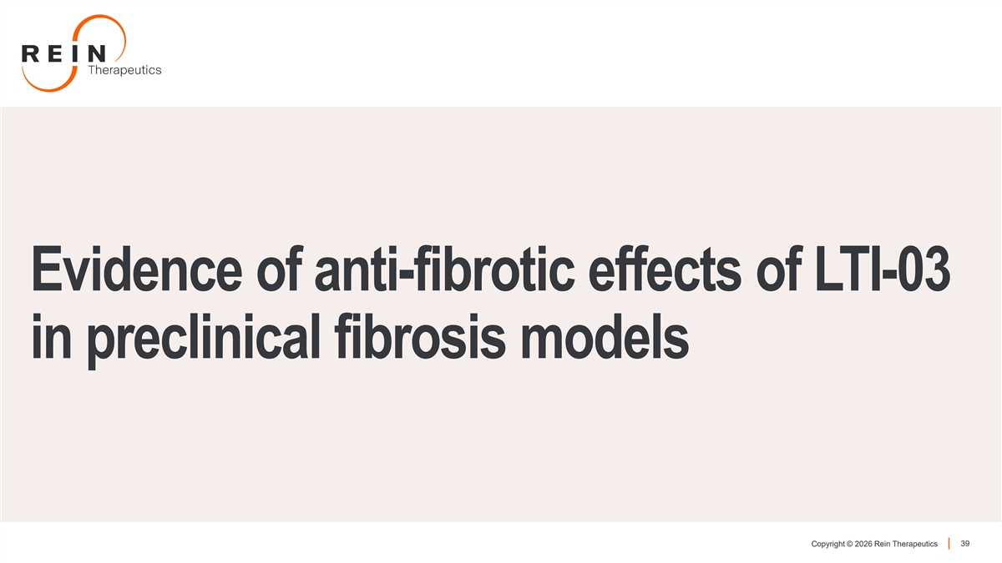
Evidence of anti-fibrotic effects of LTI-03 in preclinical fibrosis models Copyright © 2026 Rein Therapeutics 39

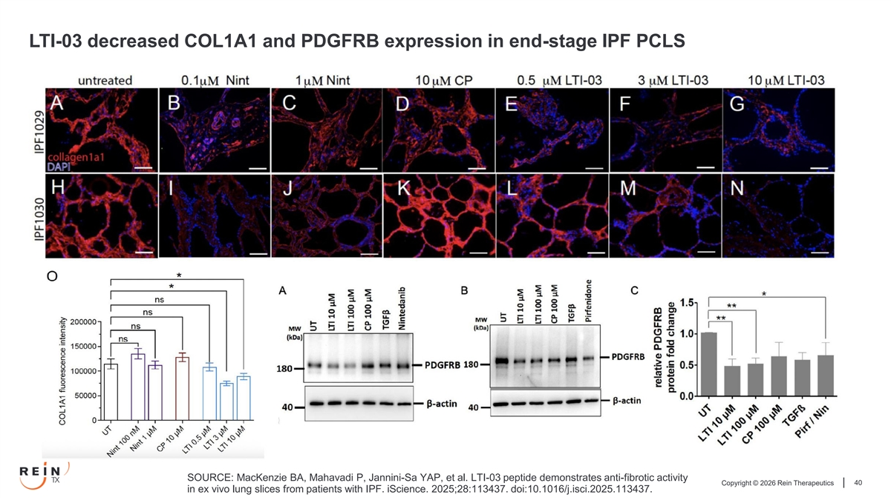
LTI-03 decreased COL1A1 and PDGFRB expression in end-stage IPF PCLS SOURCE: MacKenzie BA, Mahavadi P, Jannini-Sa YAP, et al. LTI-03 peptide demonstrates anti-fibrotic activity Copyright © 2026 Rein Therapeutics 40 in ex vivo lung slices from patients with IPF. iScience. 2025;28:113437. doi:10.1016/j.isci.2025.113437.

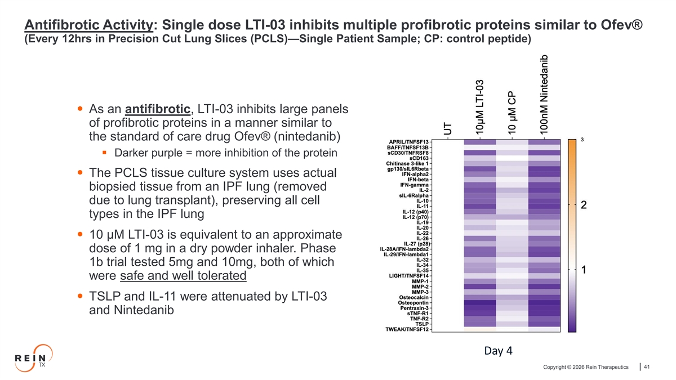
Antifibrotic Activity: Single dose LTI-03 inhibits multiple profibrotic proteins similar to Ofev® (Every 12hrs in Precision Cut Lung Slices (PCLS)—Single Patient Sample; CP: control peptide) • As an antifibrotic, LTI-03 inhibits large panels of profibrotic proteins in a manner similar to the standard of care drug Ofev® (nintedanib) ▪ Darker purple = more inhibition of the protein • The PCLS tissue culture system uses actual biopsied tissue from an IPF lung (removed due to lung transplant), preserving all cell types in the IPF lung • 10 µM LTI-03 is equivalent to an approximate dose of 1 mg in a dry powder inhaler. Phase 1b trial tested 5mg and 10mg, both of which were safe and well tolerated • TSLP and IL-11 were attenuated by LTI-03 and Nintedanib Day 4 Copyright © 2026 Rein Therapeutics 41

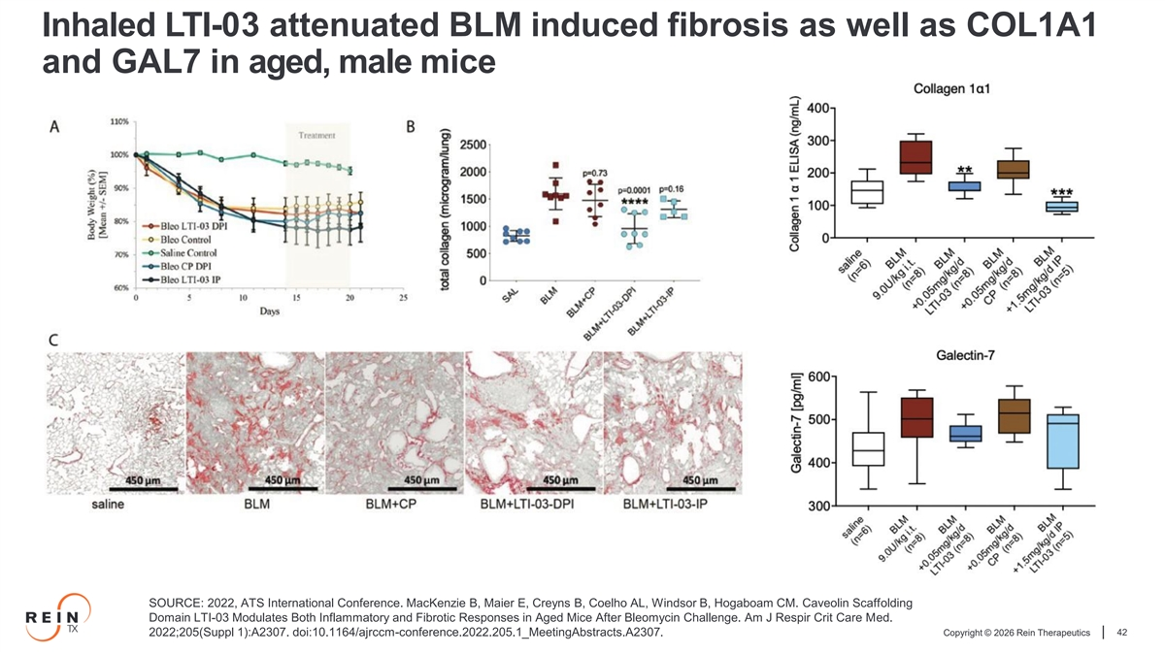
Inhaled LTI-03 attenuated BLM induced fibrosis as well as COL1A1 and GAL7 in aged, male mice SOURCE: 2022, ATS International Conference. MacKenzie B, Maier E, Creyns B, Coelho AL, Windsor B, Hogaboam CM. Caveolin Scaffolding Domain LTI-03 Modulates Both Inflammatory and Fibrotic Responses in Aged Mice After Bleomycin Challenge. Am J Respir Crit Care Med. Copyright © 2026 Rein Therapeutics 42 2022;205(Suppl 1):A2307. doi:10.1164/ajrccm-conference.2022.205.1_MeetingAbstracts.A2307.

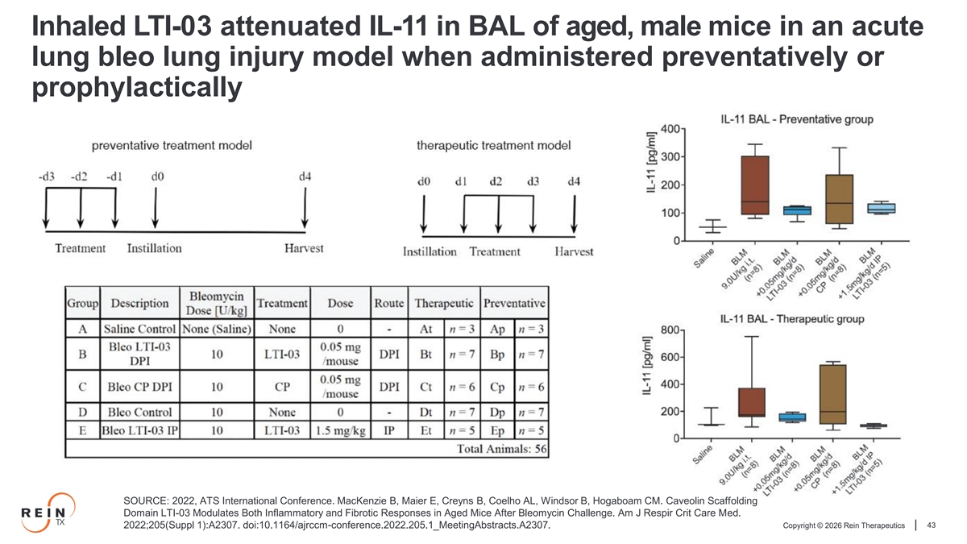
Inhaled LTI-03 attenuated IL-11 in BAL of aged, male mice in an acute lung bleo lung injury model when administered preventatively or prophylactically SOURCE: 2022, ATS International Conference. MacKenzie B, Maier E, Creyns B, Coelho AL, Windsor B, Hogaboam CM. Caveolin Scaffolding Domain LTI-03 Modulates Both Inflammatory and Fibrotic Responses in Aged Mice After Bleomycin Challenge. Am J Respir Crit Care Med. Copyright © 2026 Rein Therapeutics 43 2022;205(Suppl 1):A2307. doi:10.1164/ajrccm-conference.2022.205.1_MeetingAbstracts.A2307.

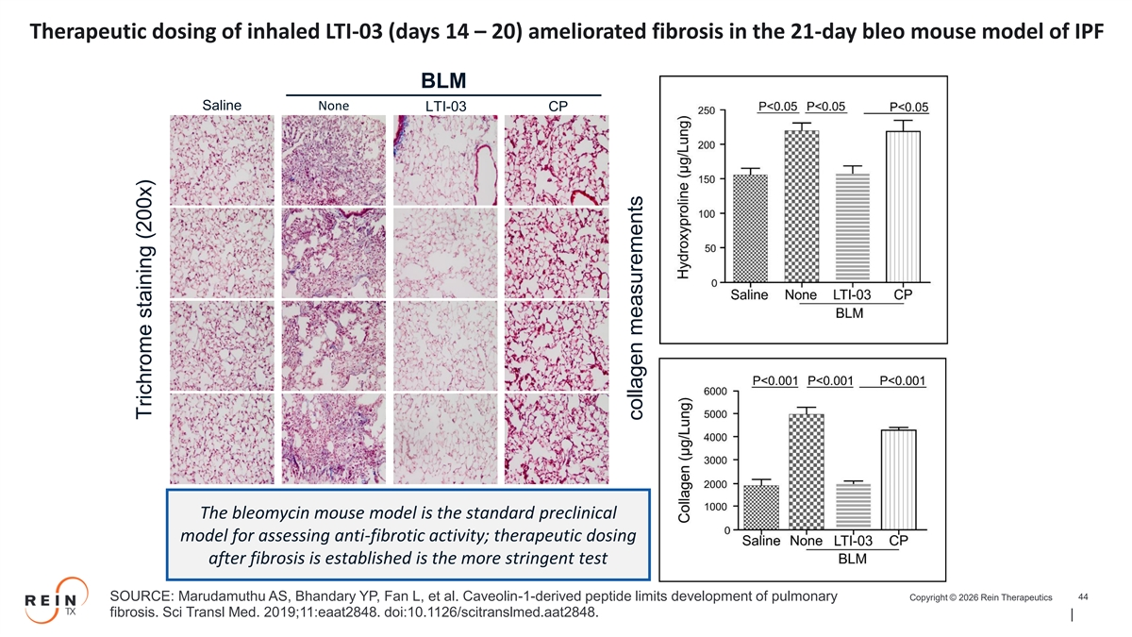
Therapeutic dosing of inhaled LTI-03 (days 14 – 20) ameliorated fibrosis in the 21-day bleo mouse model of IPF BLM Saline None LTI-03 CP The bleomycin mouse model is the standard preclinical model for assessing anti-fibrotic activity; therapeutic dosing after fibrosis is established is the more stringent test Copyright © 2026 Rein Therapeutics 44 SOURCE: Marudamuthu AS, Bhandary YP, Fan L, et al. Caveolin-1-derived peptide limits development of pulmonary fibrosis. Sci Transl Med. 2019;11:eaat2848. doi:10.1126/scitranslmed.aat2848. Trichrome staining (200x) collagen measurements

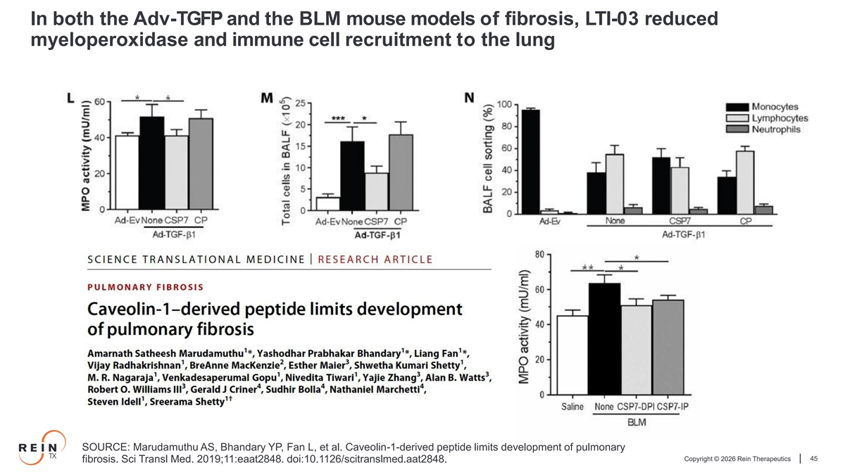
In both the Adv-TGFP and the BLM mouse models of fibrosis, LTI-03 reduced myeloperoxidase and immune cell recruitment to the lung SOURCE: Marudamuthu AS, Bhandary YP, Fan L, et al. Caveolin-1-derived peptide limits development of pulmonary Copyright © 2026 Rein Therapeutics 45 fibrosis. Sci Transl Med. 2019;11:eaat2848. doi:10.1126/scitranslmed.aat2848.

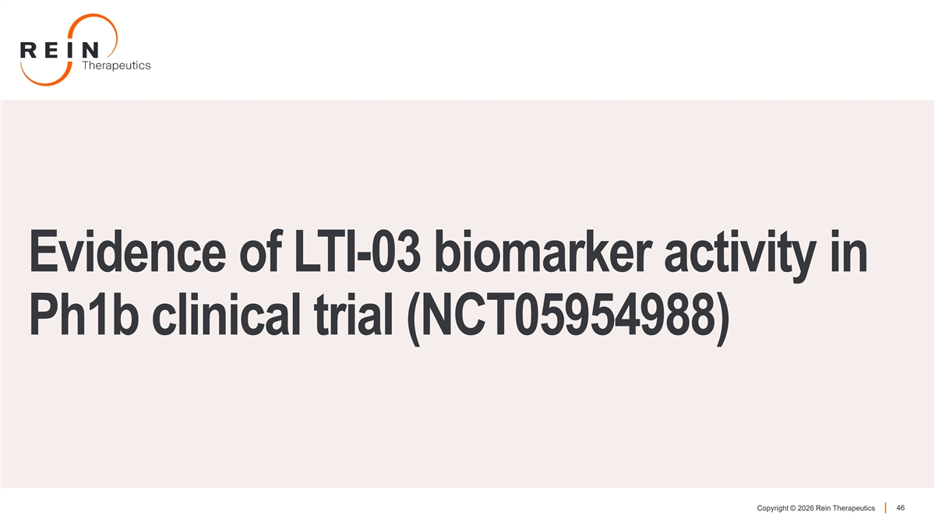
Evidence of LTI-03 biomarker activity in Ph1b clinical trial (NCT05954988) Copyright © 2026 Rein Therapeutics 46

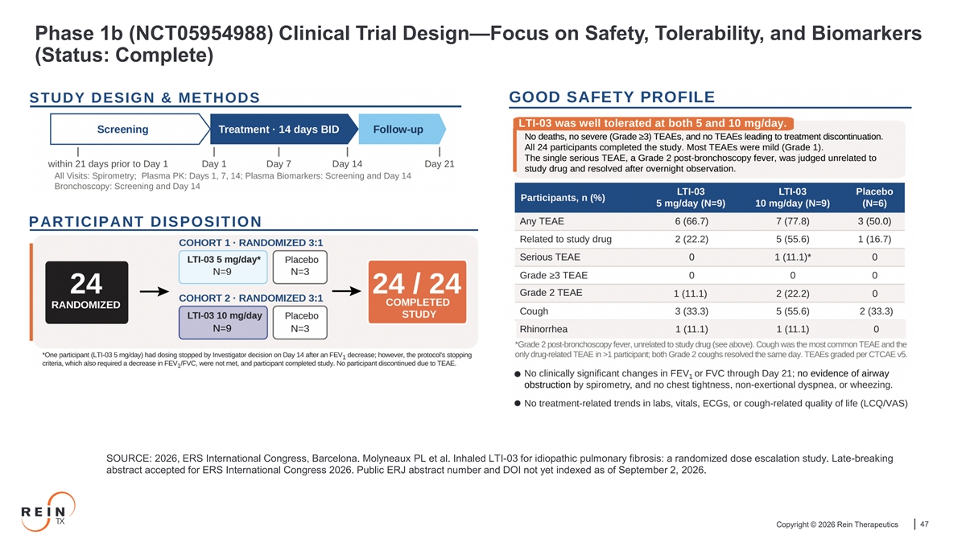
Phase 1b (NCT05954988) Clinical Trial Design—Focus on Safety, Tolerability, and Biomarkers (Status: Complete) SOURCE: 2026, ERS International Congress, Barcelona. Molyneaux PL et al. Inhaled LTI-03 for idiopathic pulmonary fibrosis: a randomized dose escalation study. Late-breaking abstract accepted for ERS International Congress 2026. Public ERJ abstract number and DOI not yet indexed as of September 2, 2026. Copyright © 2026 Rein Therapeutics 47

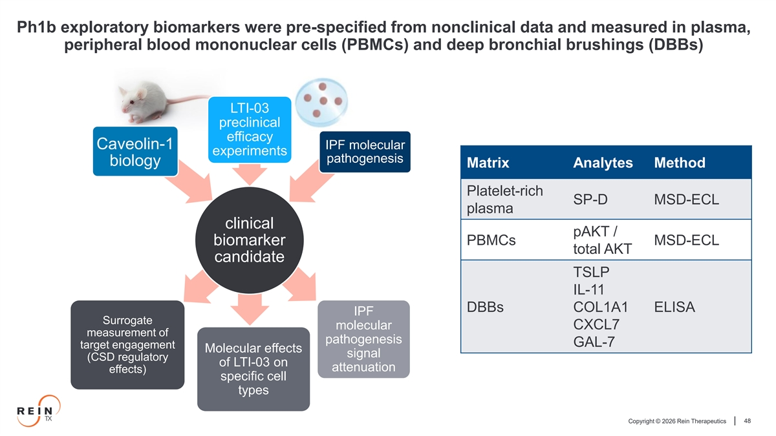
Ph1b exploratory biomarkers were pre-specified from nonclinical data and measured in plasma, peripheral blood mononuclear cells (PBMCs) and deep bronchial brushings (DBBs) LTI-03 preclinical efficacy Caveolin-1 IPF molecular experiments pathogenesis biology Matrix Analytes Method Platelet-rich SP-D MSD-ECL plasma clinical pAKT / biomarker PBMCs MSD-ECL total AKT candidate TSLP IL-11 DBBs COL1A1 ELISA IPF Surrogate molecular CXCL7 measurement of pathogenesis GAL-7 target engagement Molecular effects signal (CSD regulatory of LTI-03 on attenuation effects) specific cell types Copyright © 2026 Rein Therapeutics 48

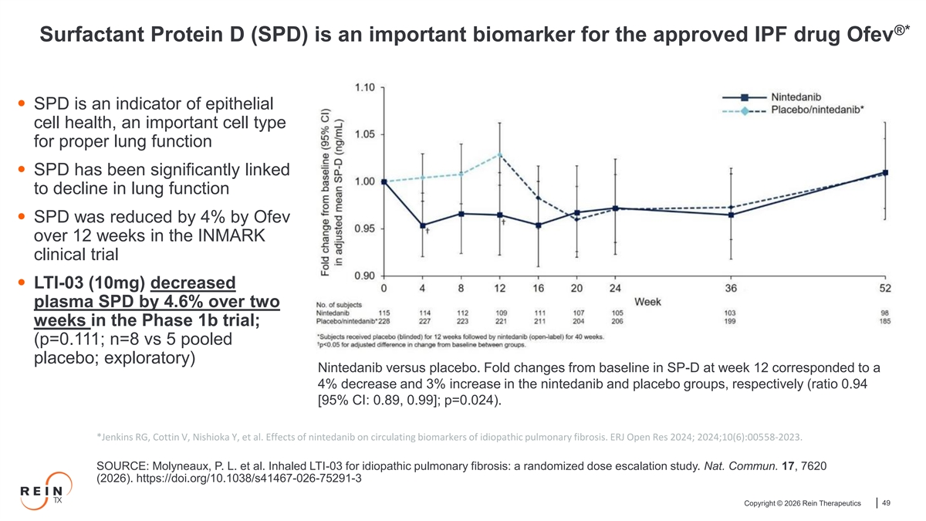
®️ * Surfactant Protein D (SPD) is an important biomarker for the approved IPF drug Ofev • SPD is an indicator of epithelial cell health, an important cell type for proper lung function • SPD has been significantly linked to decline in lung function • SPD was reduced by 4% by Ofev over 12 weeks in the INMARK clinical trial • LTI-03 (10mg) decreased plasma SPD by 4.6% over two weeks in the Phase 1b trial; (p=0.111; n=8 vs 5 pooled placebo; exploratory) Nintedanib versus placebo. Fold changes from baseline in SP-D at week 12 corresponded to a 4% decrease and 3% increase in the nintedanib and placebo groups, respectively (ratio 0.94 [95% CI: 0.89, 0.99]; p=0.024). *Jenkins RG, Cottin V, Nishioka Y, et al. Effects of nintedanib on circulating biomarkers of idiopathic pulmonary fibrosis. ERJ Open Res 2024; 2024;10(6):00558-2023. SOURCE: Molyneaux, P. L. et al. Inhaled LTI-03 for idiopathic pulmonary fibrosis: a randomized dose escalation study. Nat. Commun. 17, 7620 (2026). https://doi.org/10.1038/s41467-026-75291-3 Copyright © 2026 Rein Therapeutics 49

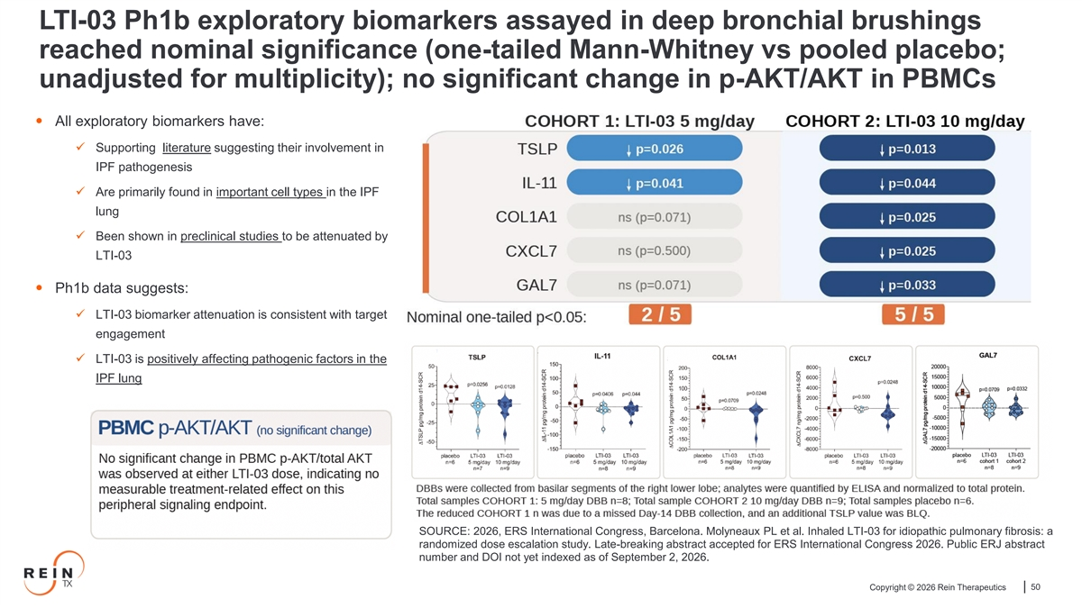
LTI-03 Ph1b exploratory biomarkers assayed in deep bronchial brushings reached nominal significance (one-tailed Mann-Whitney vs pooled placebo; unadjusted for multiplicity); no significant change in p-AKT/AKT in PBMCs • All exploratory biomarkers have: ✓ Supporting literature suggesting their involvement in IPF pathogenesis ✓ Are primarily found in important cell types in the IPF lung ✓ Been shown in preclinical studies to be attenuated by LTI-03 • Ph1b data suggests: ✓ LTI-03 biomarker attenuation is consistent with target engagement ✓ LTI-03 is positively affecting pathogenic factors in the IPF lung SOURCE: 2026, ERS International Congress, Barcelona. Molyneaux PL et al. Inhaled LTI-03 for idiopathic pulmonary fibrosis: a randomized dose escalation study. Late-breaking abstract accepted for ERS International Congress 2026. Public ERJ abstract number and DOI not yet indexed as of September 2, 2026. Copyright © 2026 Rein Therapeutics 50

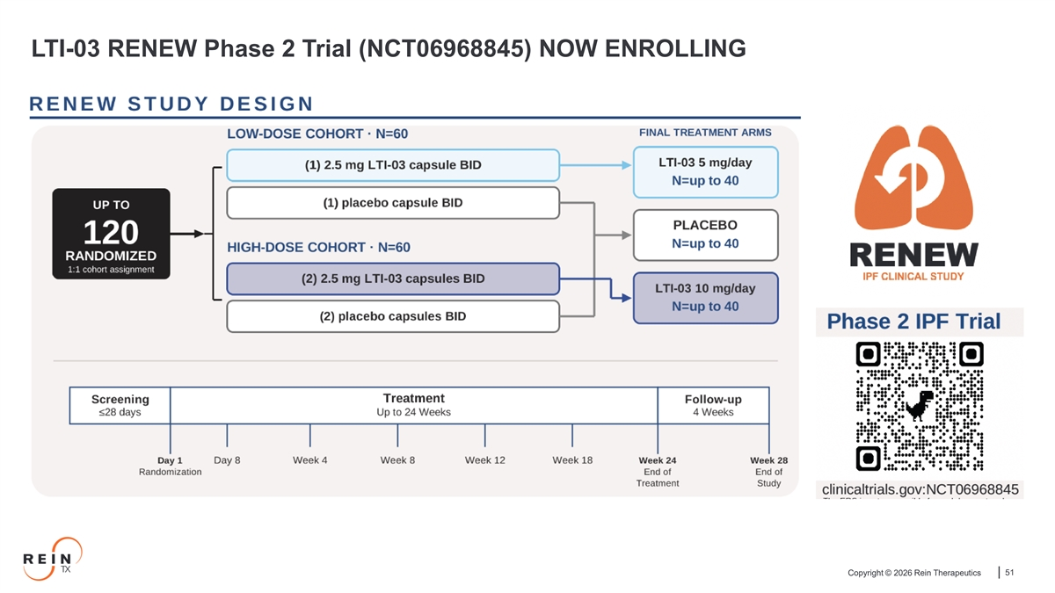
LTI-03 RENEW Phase 2 Trial (NCT06968845) NOW ENROLLING Copyright © 2026 Rein Therapeutics 51


Nasdaq: RNTX Copyright © 2026 Rein Therapeutics

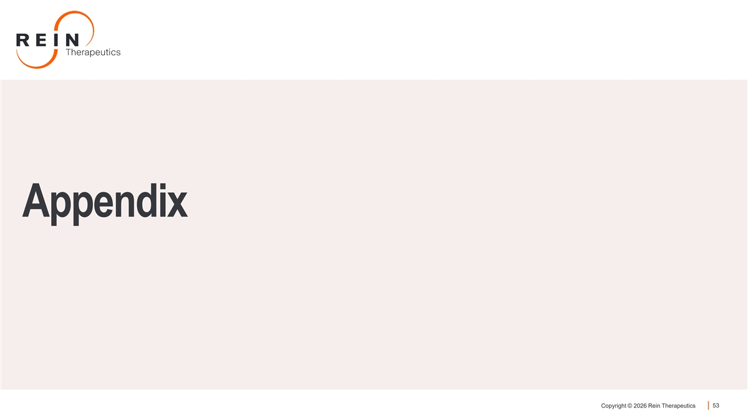
Appendix Copyright © 2026 Rein Therapeutics 53

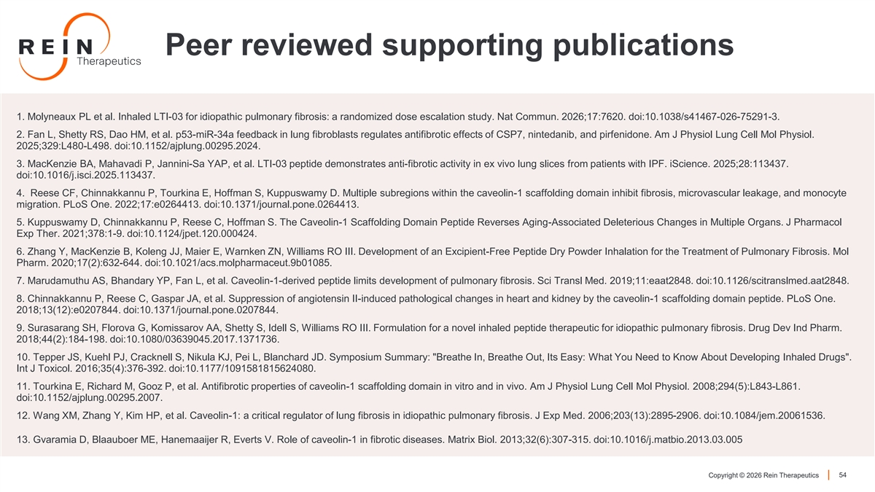
Peer reviewed supporting publications 1. Molyneaux PL et al. Inhaled LTI-03 for idiopathic pulmonary fibrosis: a randomized dose escalation study. Nat Commun. 2026;17:7620. doi:10.1038/s41467-026-75291-3. 2. Fan L, Shetty RS, Dao HM, et al. p53-miR-34a feedback in lung fibroblasts regulates antifibrotic effects of CSP7, nintedanib, and pirfenidone. Am J Physiol Lung Cell Mol Physiol. 2025;329:L480-L498. doi:10.1152/ajplung.00295.2024. 3. MacKenzie BA, Mahavadi P, Jannini-Sa YAP, et al. LTI-03 peptide demonstrates anti-fibrotic activity in ex vivo lung slices from patients with IPF. iScience. 2025;28:113437. doi:10.1016/j.isci.2025.113437. 4. Reese CF, Chinnakkannu P, Tourkina E, Hoffman S, Kuppuswamy D. Multiple subregions within the caveolin-1 scaffolding domain inhibit fibrosis, microvascular leakage, and monocyte migration. PLoS One. 2022;17:e0264413. doi:10.1371/journal.pone.0264413. 5. Kuppuswamy D, Chinnakkannu P, Reese C, Hoffman S. The Caveolin-1 Scaffolding Domain Peptide Reverses Aging-Associated Deleterious Changes in Multiple Organs. J Pharmacol Exp Ther. 2021;378:1-9. doi:10.1124/jpet.120.000424. 6. Zhang Y, MacKenzie B, Koleng JJ, Maier E, Warnken ZN, Williams RO III. Development of an Excipient-Free Peptide Dry Powder Inhalation for the Treatment of Pulmonary Fibrosis. Mol Pharm. 2020;17(2):632-644. doi:10.1021/acs.molpharmaceut.9b01085. 7. Marudamuthu AS, Bhandary YP, Fan L, et al. Caveolin-1-derived peptide limits development of pulmonary fibrosis. Sci Transl Med. 2019;11:eaat2848. doi:10.1126/scitranslmed.aat2848. 8. Chinnakkannu P, Reese C, Gaspar JA, et al. Suppression of angiotensin II-induced pathological changes in heart and kidney by the caveolin-1 scaffolding domain peptide. PLoS One. 2018;13(12):e0207844. doi:10.1371/journal.pone.0207844. 9. Surasarang SH, Florova G, Komissarov AA, Shetty S, Idell S, Williams RO III. Formulation for a novel inhaled peptide therapeutic for idiopathic pulmonary fibrosis. Drug Dev Ind Pharm. 2018;44(2):184-198. doi:10.1080/03639045.2017.1371736. 10. Tepper JS, Kuehl PJ, Cracknell S, Nikula KJ, Pei L, Blanchard JD. Symposium Summary: Breathe In, Breathe Out, Its Easy: What You Need to Know About Developing Inhaled Drugs . Int J Toxicol. 2016;35(4):376-392. doi:10.1177/1091581815624080. 11. Tourkina E, Richard M, Gooz P, et al. Antifibrotic properties of caveolin-1 scaffolding domain in vitro and in vivo. Am J Physiol Lung Cell Mol Physiol. 2008;294(5):L843-L861. doi:10.1152/ajplung.00295.2007. 12. Wang XM, Zhang Y, Kim HP, et al. Caveolin-1: a critical regulator of lung fibrosis in idiopathic pulmonary fibrosis. J Exp Med. 2006;203(13):2895-2906. doi:10.1084/jem.20061536. 13. Gvaramia D, Blaauboer ME, Hanemaaijer R, Everts V. Role of caveolin-1 in fibrotic diseases. Matrix Biol. 2013;32(6):307-315. doi:10.1016/j.matbio.2013.03.005 Copyright © 2026 Rein Therapeutics 54

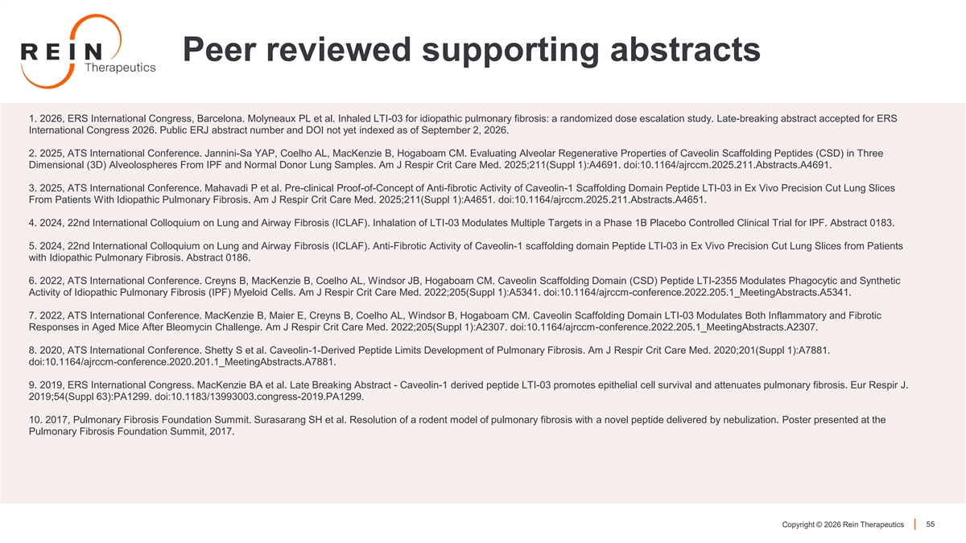
Peer reviewed supporting abstracts 1. 2026, ERS International Congress, Barcelona. Molyneaux PL et al. Inhaled LTI-03 for idiopathic pulmonary fibrosis: a randomized dose escalation study. Late-breaking abstract accepted for ERS International Congress 2026. Public ERJ abstract number and DOI not yet indexed as of September 2, 2026. 2. 2025, ATS International Conference. Jannini-Sa YAP, Coelho AL, MacKenzie B, Hogaboam CM. Evaluating Alveolar Regenerative Properties of Caveolin Scaffolding Peptides (CSD) in Three Dimensional (3D) Alveolospheres From IPF and Normal Donor Lung Samples. Am J Respir Crit Care Med. 2025;211(Suppl 1):A4691. doi:10.1164/ajrccm.2025.211.Abstracts.A4691. 3. 2025, ATS International Conference. Mahavadi P et al. Pre-clinical Proof-of-Concept of Anti-fibrotic Activity of Caveolin-1 Scaffolding Domain Peptide LTI-03 in Ex Vivo Precision Cut Lung Slices From Patients With Idiopathic Pulmonary Fibrosis. Am J Respir Crit Care Med. 2025;211(Suppl 1):A4651. doi:10.1164/ajrccm.2025.211.Abstracts.A4651. 4. 2024, 22nd International Colloquium on Lung and Airway Fibrosis (ICLAF). Inhalation of LTI-03 Modulates Multiple Targets in a Phase 1B Placebo Controlled Clinical Trial for IPF. Abstract 0183. 5. 2024, 22nd International Colloquium on Lung and Airway Fibrosis (ICLAF). Anti-Fibrotic Activity of Caveolin-1 scaffolding domain Peptide LTI-03 in Ex Vivo Precision Cut Lung Slices from Patients with Idiopathic Pulmonary Fibrosis. Abstract 0186. 6. 2022, ATS International Conference. Creyns B, MacKenzie B, Coelho AL, Windsor JB, Hogaboam CM. Caveolin Scaffolding Domain (CSD) Peptide LTI-2355 Modulates Phagocytic and Synthetic Activity of Idiopathic Pulmonary Fibrosis (IPF) Myeloid Cells. Am J Respir Crit Care Med. 2022;205(Suppl 1):A5341. doi:10.1164/ajrccm-conference.2022.205.1_MeetingAbstracts.A5341. 7. 2022, ATS International Conference. MacKenzie B, Maier E, Creyns B, Coelho AL, Windsor B, Hogaboam CM. Caveolin Scaffolding Domain LTI-03 Modulates Both Inflammatory and Fibrotic Responses in Aged Mice After Bleomycin Challenge. Am J Respir Crit Care Med. 2022;205(Suppl 1):A2307. doi:10.1164/ajrccm-conference.2022.205.1_MeetingAbstracts.A2307. 8. 2020, ATS International Conference. Shetty S et al. Caveolin-1-Derived Peptide Limits Development of Pulmonary Fibrosis. Am J Respir Crit Care Med. 2020;201(Suppl 1):A7881. doi:10.1164/ajrccm-conference.2020.201.1_MeetingAbstracts.A7881. 9. 2019, ERS International Congress. MacKenzie BA et al. Late Breaking Abstract - Caveolin-1 derived peptide LTI-03 promotes epithelial cell survival and attenuates pulmonary fibrosis. Eur Respir J. 2019;54(Suppl 63):PA1299. doi:10.1183/13993003.congress-2019.PA1299. 10. 2017, Pulmonary Fibrosis Foundation Summit. Surasarang SH et al. Resolution of a rodent model of pulmonary fibrosis with a novel peptide delivered by nebulization. Poster presented at the Pulmonary Fibrosis Foundation Summit, 2017. Copyright © 2026 Rein Therapeutics 55

